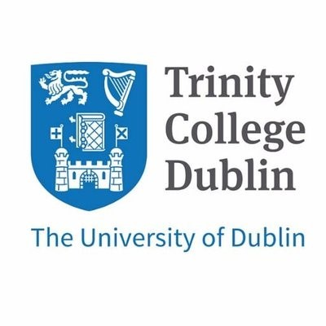
STUDENT VISA FAQs
& GDPR Consent Form
Trinity College Dublin, at Belfast

The following pages provide an overview of visas for prospective students applying to the MPhil in Conflict Resolution and Reconciliation or PhD study at Belfast.

Please read carefully, complete the data consent section, and return to: sradmblfst@tcd.ie.

Will I need a UK Student Visa?

If you are an international student, you are likely to need a UK student visa to study in Belfast. This includes EU and EEA citizens (except Irish nationals and those with settled or pre-settled status in the UK).
LEARN MORE.

What do I need to apply for my UK Student Visa?

You must have accepted an unconditional offer for your course.

A CAS (Confirmation of Acceptance for Studies) provided by us.

Valid passport.

Financial Requirements
Please read the financial requirements. If your country qualifies for ‘differential evidence requirements’ (listed at the link below) there will be fewer checks on finances. Students who don’t qualify for these arrangements should familiarise themselves with how much money they will need to have, for how long and in what types of bank account.
LEARN MORE

When do I apply?
If applying from outside the UK, the earliest you can apply is 6 months before the start of your course (3 months if applying from inside the UK).

How long does it take?
You should usually expect to get a decision within 3 weeks.

Can I bring dependents?
Since January 2024 only PhD students can bring their partner or children.

Healthcare Surcharge

As part of the visa application, a healthcare surcharge is payable, currently £776 for each 12-month period which entitles students to access the National Health Service (NHS). Please note, those applying for a visa to undertake a PhD will need to meet the costs of the healthcare surcharge covering the full course period up-front, and the same applies to any dependants.

What form does my visa take?
You will receive a digital visa and a share code to give to anyone who needs to verify your immigration status. Please share the code with the CRR office once available: email sradmblst@tcd.ie. When arriving in the UK or Ireland, you may pass through an e-passport gate. Your visa is digitally connected to the passport you used for the visa application, so if renewing your passport before travelling, be sure to update details in your UK visa account.

When can I travel?
It is important that you arrive on or after the start date of your visa, otherwise it will not be activated! UK Visas require universities to know the date of students’ arrival in the UK. We will ask that you email a copy of your flight ticket once available. In the first few weeks of term, we will arrange to collect passports to take a copy of any entry stamps as a record of arrival dates.

Can I work alongside my studies?

Yes, normally a student visa permits you to work for 20 hours per week during term time and full-time during holidays. This will be shown on your visa. There are limitations to the type of work students can undertake. You cannot be self-employed, carry out business activity or work full time during term time (this includes the summer months when you are writing your dissertation).

Please note: the Conflict Resolution course includes an optional internship, Community Learning and Reflective Practice, and this is covered by the student visa. It is also worth knowing that other additional study outside your main course is permitted, such as evening classes.

How long can I stay on a UK student visa?

Students are normally granted leave to arrive in the UK a month before the course start date and stay for 4 months after the course ends. Orientation and the start of teaching is usually in the 2nd week of September and the course end date is 31st August. Dates will be confirmed as soon as available.

Can I apply for the Graduate Visa after my studies?
Yes, you can apply if you have successfully completed your course, and this has been verified by the School. You must be inside the UK and apply before the student visa expiry date. You can’t leave the country while your application is being processed so make sure to take any travel plans into account. The earliest you can apply is 1st September at the end of your studies.
LEARN MORE.

Can you tell me more about my CAS on the UKVI system?

The CAS remains a live document on the UKVI system for the period of study and some changes to student circumstances need to be reported. These include: not starting the course having obtained a visa or withdrawing from the course.

Will I need an Irish visa to study in Belfast?

No! Attendance at the main Trinity campus in Dublin is not required as the whole course is delivered in Belfast. For those students who do wish to travel to Dublin, most will not need a visa, but there may be a requirement to obtain a short Irish visitor C visa for up to 3 months for some students depending on nationality. Do ensure that if you plan to arrive via Dublin airport at the start of your studies and are visa-required, that you obtain the necessary visa before travelling.

It is worth noting that as part of the application you will need to post off your passport so do consider any travel plans. For example, if travelling home for Christmas, wait until you return to Belfast before applying. A Dublin field trip normally takes place in March/April, so applying for an Irish visitor visa in January would work well.
LEARN MORE.

GDPR Consent Declaration

What personal data do you keep for students on a UK visa?

Copy of passport

Copy of CAS (confirmation of acceptance for studies)

Date of entry to UK in form of a flight ticket/entry stamp in passport

Copy of digital visa

Term time contact details

The above records are kept for compliance with legal requirements and according to the College GDPR Policy. Documents are securely stored and deleted one year after the period of study has come to an end.

Please note: personal data such as date of birth and passport number must be provided by the School to UKVI to issue a CAS.

☐ I (insert name ) CONSENT TO THE USE OF MY PERSONAL DATA FOR THE PURPOSES OUTLINED.

