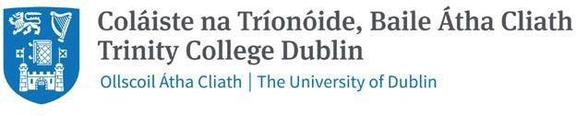

Wednesday 7 August 2024

Dear Students,

Welcome to the School of Medicine, Trinity College Dublin, as new members of our School and University community. We hope you are all keeping well and looking forward with excitement, and no doubt some trepidation, to the opportunities and challenges we will navigate together over the course of the next 5 years.

We are extremely proud of the achievements of our students and alumni who are wonderful ambassadors for the School and we are confident that you will bring a rich and rewarding contribution to our student body and to the wider University community here in Dublin.

Please see information below in relation to the Year 1 schedule. Please note these dates are specific to the Medicine programme and may not align with the general College Calendar.

* Orientation week (in person events) will commence on **Monday 16th September,** a little later this year due to a later release date for our local Leaving Certificate Examination results.
* Teaching will commence on **Monday 23rd September.**
* There will be a reading week **Monday 21st October**.
* Semester 1 examinations will likely take place week of **Monday 6th January**, **2025.**

The Overview of Year 1 is available online and the detailed timetable with student groupings for small group teaching events will be available in mid-September. The following links provide important advice and guidance for new entrants to the School/University:

Incoming Year 1 Medicine <https://www.tcd.ie/medicine/undergraduate-medicine/incoming-year-1-students-202425/>

Student Orientation <https://www.tcd.ie/students/orientation>

We look forward to meeting you in September and we hope that you enjoy the summer break.

With best wishes to you all and to your families.

Professor Richard Deane

Director of Undergraduate Teaching and Learning

**Professor Colin Doherty**

Head of School

**Ms Áine Wade**

Programme Manager