The information provided in this document is not legal advice or professional advice of any other kind, and should not be considered to be such, or relied or acted upon in that regard. If you need legal or other professional advice, you should consult a suitably qualified person.

To the extent permitted by law, Trinity College Dublin and the authors of this document, and their respective servants or agents, assume and accept no responsibility for, and give no guarantees, undertakings or warranties concerning, the accuracy, clarity, comprehensiveness, completeness, timeliness, fitness-for-purpose, up-to-date nature, reliability, or otherwise, of the information provided in this document, and do not accept any liability whatsoever in respect of, or arising from, any errors or omissions or any reliance on, or use of, such information.

Whilst we have taken reasonable care in preparing this document, to the extent permitted by law, we accept no responsibility for any loss or damage claimed to arise from any reliance on, or action taken by any person or organisation, wherever they are based, as a result, direct or otherwise, of, information contained in, or accessed through, this document, whether such information is provided by us or by a third party.

If you identify any errors or omissions in this document, please email us at [covid.observatory@tcd.ie](mailto:covid.observatory@tcd.ie).

31 August 2020

**Table of Contents**

S.I. No. 234/2020 - Health Act 1947 (Section 31A -Temporary Restrictions) (Covid-19) (No. 3) Regulations 2020 3

Table of Regulations amending the Temporary Restrictions (No. 3) Regulations 6

S.I. No. 120/2020 - Health Act 1947 (Affected Areas) Order 2020 7

Table of Regulations amending the Affected Areas Order 8

S.I. No. 181/2020 - Health Act 1947 (Section 31A -Temporary Requirements) (Covid-19 Passenger Locator Form) Regulations 2020 9

Table of Regulations amending the Temporary Requirements (COVID-19 Passenger Locator Form) Regulations 27

S.I. No. 244/2020 - Health Act 1947 (Section 31A -Temporary Restrictions) (Covid-19) (Face Coverings on Public Transport) Regulations 2020 29

Table of Regulations amending the Temporary Restrictions (COVID-19) (Face Coverings on Public Transport) Regulations 33

S.I. No. 295/2020 - Health Act 1947 (Section 31A -Temporary Restrictions) (Covid-19) (Relevant Counties) Regulations 2020 34

Table of Regulations amending the Temporary Restrictions (COVID-19) (Relevant Counties) Regulations 45

S.I. No. 296/2020 - Health Act 1947 (Section 31A -Temporary Restrictions) (Covid-19) (Face Coverings in Certain Premises and Businesses) Regulations 2020 46

Table of Regulations amending the Temporary Restrictions (COVID-19) (Face Covering in Certain Premises and Businesses) Regulations 51

# **S.I. No. 234/2020 - Health Act 1947 (Section 31A -Temporary Restrictions) (Covid-19) (No. 3) Regulations 2020**

*Notice of the making of this Statutory Instrument was published in “Iris Oifigiúil” of* 30*th June,* 2020*.*

The Minister for Health, in exercise of the powers conferred on him by sections 5 and 31A (inserted by section 10 of the Health (Preservation and Protection and other Emergency Measures in the Public Interest) Act 2020 (No. 1 of 2020)) of the Health Act 1947 (No. 28 of 1947) and –

(*a*)  having regard to the immediate, exceptional and manifest risk posed to human life and public health by the spread of Covid-19 and to the matters specified in subsection (2) of section 31A, and

(*b*)  having consulted with the Minister for Finance, the Minister for Public Expenditure and Reform, the Minister for Justice and Equality, the Minister for Transport, Tourism and Sport and the Minister for Business, Enterprise and Innovation,

hereby makes the following regulations:

**Citation and commencement**

1. (1) These Regulations may be cited as the Health Act 1947 (Section 31A – Temporary Restrictions) (Covid-19) (No. 3) Regulations 2020.

(2) These Regulations shall come into operation on the 29th day of June

**Operation of Regulations**

2. These Regulations shall remain in operation until the 31st day of August

**Revocation**

3. The Health Act 1947 (Section 31A – Temporary Restrictions) (Covid- 19) (No. 2) Regulations 2020 (S.I. No. 206 of 2020) are revoked.

**Definitions**

4. In these Regulations –  
“Act of 1947” means the Health Act 1947 (No. 28 of 1947);

“relevant geographical location” means a geographical location to which an affected areas order applies.

**Restriction on events**

5. (1) Subject to paragraph (2), a person shall not organise, or cause to be organised, an event for cultural, entertainment, recreational, sporting, social, community or educational reasons in a relevant geographical location other than where one or more of the following applies:

1. (*a*)  in the case of an indoor event, the maximum number of persons attending, or proposed to attend, the event (for whatever reason) does not exceed 50 persons;
2. (*b*)  in the case of an outdoor event, the maximum number of persons attending, or proposed to attend, the event (for whatever reason) does not exceed 200 persons;
3. (*c*)  the person so organising, or so causing to be organised, the event takes all reasonable steps to ensure that the number of persons attending, or proposed to attend, the event (for whatever reason) does not exceed, in the case of an indoor event, 50 persons, and in the case of an outdoor event, 200 persons.

(2) This Regulation shall not apply to an event held, or proposed to be held, in a private dwelling.

(3) Paragraph (1) is a penal provision for the purposes of section 31A of the Act of 1947.

**Carrying on or provision of certain businesses or services**

6. (1) A relevant person shall take all reasonable steps to ensure that members of the public are not permitted, or otherwise granted, access to a premises in a relevant geographical location, or to a part of such premises, where a business or service of a type specified in paragraph (2) is carried on or otherwise provided.

(2) The following types of businesses and services are specified for the purposes of paragraph (1):

(*a*)  a nightclub or discotheque, including those licenced under the Public Dance Halls Act 1935 (No. 2 of 1935);

(*b*)  a casino or Private Members’ Club at which gambling activities are carried out and which is operated on a commercial basis;

(*c*)  any other business or service that is selling or supplying intoxicating liquor for consumption on the premises and that, but for this Regulation, is otherwise permitted by law to do so, other than where such intoxicating liquor is –

(i)  ordered by or on behalf of the member of the public being permitted, or otherwise granted, access to the premises, at the same time as a substantial meal is so ordered, during the meal or after the meal has ended, and

(ii)  consumed by that member during the meal or after the meal has ended.

(3) Paragraph (1) is a penal provision for the purposes of section 31A of the Act of 1947.  
(4) In this Regulation –

“relevant person”, in relation to a premises, or part of such premises, where a business or service of a type specified in paragraph (2) is carried on or otherwise provided, means –

(*a*)  the occupier,

(*b*)  the manager, or

(*c*)  any other person for the time being in charge,

of the premises, or part of the premises, concerned;

“substantial meal” means a meal –

(*a*)  such as might be expected to be served as a main midday or main evening meal or as a main course at either such meal, and

(*b*)  that is of a kind, having regard to all the circumstances, for which it would be reasonable to charge a sum that is not less than €9.

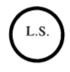

GIVEN under the Official Seal of the Minister for Health, 26 June, 2020.

SIMON HARRIS, Minister for Health.

# **Table of Regulations amending the Temporary Restrictions (No. 3) Regulations**

|  |  |  |
| --- | --- | --- |
|  |  |  |
| |  |  |  | | --- | --- | --- | | **Title** | **Date made** | **Iris Oifigiúil** | | S.I. No. 252/2020 – Health Act 1947 (Section 31A – Temporary Restrictions) (Covid-19) (No. 3) (Amendment) Regulations 2020 | 18/07/2020 | 21/07/2020 | | S.I. No. 298/2020 – Health Act 1947 (Section 31A – Temporary Restrictions) (Covid-19) (No. 3) (Amendment) (No. 2) Regulations 2020 | 9/08/2020 | 11/08/2020 | |  |  |  | | | | |
|  |  |  |

|  |  |  |
| --- | --- | --- |
|  |  |  |

# **S.I. No. 120/2020 - Health Act 1947 (Affected Areas) Order 2020**

|  |  |  |
| --- | --- | --- |
|  |  | *Notice of the making of this Statutory Instrument was published in* |
|  |  | *“Iris Oifigiúil” of* 10*th April*, 2020. |
|  |  | The Minister for Health, in the exercise of the powers conferred on him by section 31B of the [Health Act 1947](http://www.irishstatutebook.ie/1947/en/act/pub/0028/index.html) (No. 28 of 1947), having regard to the matters specified in section 31A(2) of that Act and to the advice of the Chief Medical Officer of the Department of Health and having consulted with the Minister for Justice and Equality, the Minister for Finance and the Minister for Public Expenditure and Reform, hereby orders as follows: |
|  |  | 1. This Order may be cited as the Health Act 1947 (Affected Areas) Order 2020. |
|  |  | 2. It is hereby declared that the State (being every area or region thereof) is an area where there is known or thought to be sustained human transmission of Covid-19. |
|  |  | /images/ls |
|  |  | GIVEN under the Official Seal of the Minister for Health, |
|  |  | 7 April, 2020. |
|  |  | SIMON HARRIS, |
|  |  | Minister for Health. |
|  |  | EXPLANATORY NOTE |
|  |  | (*This note is not part of the Instrument and does not purport to be a legal interpretation.*) |
|  |  | This Order declares that the State (being every area or region thereof) is an area where there is known or thought to be sustained human transmission of Covid-19. |

# **Table of Regulations amending the Affected Areas Order**

|  |  |  |  |  |  |  |  |  |  |  |  |  |
| --- | --- | --- | --- | --- | --- | --- | --- | --- | --- | --- | --- | --- |
| |  |  |  | | --- | --- | --- | | **Title** | **Date made** | **Iris Oifigiúil** | |  |  |  | |  |  |  | |  |  |  | |

# **S.I. No. 181/2020 - Health Act 1947 (Section 31A -Temporary Requirements) (Covid-19 Passenger Locator Form) Regulations 2020**

*Notice of the making of this Statutory Instrument was published in “Iris Oifigiúil” of 26th May, 2020.*

The Minister for Health, in exercise of the powers conferred on him by sections 5 and 31A (inserted by section 10 of the Health (Preservation and Protection and other Emergency Measures in the Public Interest) Act 2020 (No. 1 of 2020)) of the Health Act 1947 (No. 28 of 1947) and -

(a)  having regard to the immediate, exceptional and manifest risk posed to human life and public health by the spread of Covid-19 and to the matters specified in subsection (2) of section 31A, and

(b)  having consulted with the Minister for Foreign Affairs and Trade, the Minister for Justice and Equality, the Minister for Business, Enterprise and Innovation and the Minister for Transport, Tourism and Sport,

hereby makes the following regulations:

**Citation and commencement**

1. (1) These Regulations may be cited as the Health Act 1947 (Section 31A – Temporary Requirements) (Covid-19 Passenger Locator Form) Regulations 2020.

(2) These Regulations shall come into operation on the 28th day of May 2020.

**Operation of Regulations**

2. These Regulations shall remain in operation until the 9th day of November 2020.

**Definitions**

3. In these Regulations -  
“airport” means any of the following airports:

(a)  Cork Airport;

(b)  Donegal Airport;

(c)  Dublin Airport;

(d)  Ireland West Airport;

(e)  Kerry Airport;

(f)  Shannon Airport;

(g)  Waterford Airport;

“contact details”, in relation to an international passenger, means his or her

telephone number and email address;  
“Covid-19 Passenger Locator Form” means the form set out in the Schedule or a form to like effect made available by the Health Service Executive that may be completed electronically;

“international passenger” means a person, other than a child, who arrives in the State at a port or airport from a place outside the State, but does not include:

(a)  a person who arrives in the State from Northern Ireland;

(b)  a person who arrives at the port or airport for the purposes of passing through that port or airport in order to travel to another state, and who does not leave the port or airport;

(c)  an international transport worker who arrives in the State in the course of performing his or her duties;

(d)  an aircraft pilot, other aircrew, maritime master or maritime crew who arrives in the State in the course of performing his or her duties;

(e)  a person to whom the privileges and immunities conferred by -

(i) the Vienna Convention on Diplomatic Relations done at Vienna on the 18th day of April 1961, or

(ii) the Vienna Convention on Consular Relations done at Vienna on the 24th day of April 1963,

apply in the State;

(f) a person to whom the privileges and immunities conferred by an international agreement or arrangement apply in the State, pursuant to the Diplomatic Relations and Immunities Acts 1967 to 2006 or any other enactment;

“international transport worker” means a person -

(a)  who holds a valid annex 3 certificate in accordance with the Communication from the Commission on the implementation of the Green Lanes under the Guidelines for border management measures to protect health and ensure the availability of goods and essential services1, or

(b)  who is a driver of a heavy goods vehicle;

“place of residence”, in relation to an international passenger, means the place, or places, in the State at which he or she intends to reside during the relevant period;

“PLF receipt” means a receipt issued electronically by the Health Service Executive, in such form as it may specify, to an international passenger on the completion electronically by the passenger of a Covid-19 Passenger Locator Form;

“port” means any of the following ports:

(a)  Cobh in the Port of Cork;

(b)  Dublin Port;

(c)  Killybegs Harbour;

(d)  Port of Cork;

(e)  Port of Galway;

(f)  Port of Waterford;

(g)  Rosslare EuroPort;

“public health information” means public health information or advice relating to COVID-19, including measures for preventing, limiting, minimising, or slowing the spread of COVID-19;

“relevant period”, in relation to an international passenger, means -

(a)  the period of 14 days from the date on which he or she arrives in the State, or

(b)  where the duration of his or her stay in the State is less than 14 days, the period of his or her stay;

“relevant person” has the meaning assigned to it by Regulation 4;

“responsible adult” means, in relation to a child who arrives in the State at a port or airport from a place outside the State, an international passenger who is travelling with the child and who is responsible, alone or jointly with another person, for that child for all or part of the journey by which the child arrives in the State.

**Relevant persons**

4. The following persons (each of whom, in these Regulations, is referred to as a “relevant person”) are specified as relevant persons for the purposes of these Regulations:

(a)  officers of the Minister for Justice and Equality, being immigration officers appointed by that Minister under section 3 of the Immigration Act 2004 (No. 1 of 2004);

(b)  persons appointed by the Health Service Executive under the programme commonly known as the Covid-19 Contact Management Programme.

(c) any officer, employee or agent of the Health Service Executive who is acting in the course of his or her duty as such officer or agent in accordance with Regulation 6(3) or 6A;

(d) any agent of the Minister who is acting in the course of his or her duty as such agent in accordance with Regulation 6(3) or 6A.

**Covid-19 Passenger Locator Form**

5. (1) An international passenger shall -

(a)  on or before his or her arrival in the State, complete a Covid-19 Passenger Locator Form -

(i)  in respect of himself or herself, and

(ii)  subject to paragraph (2), in respect of any child in relation to whom the international passenger is a responsible adult,

(b)  on arrival in the State, present himself or herself to a relevant person, and –

(i) give the relevant person the COVID-19 Passenger Locator Form completed in accordance with paragraph (a), or

(ii) where a PLF receipt has been issued to the international passenger, make the PLF receipt available to the relevant person.

(2) Where the requirement in paragraph (1)(a)(ii) applies to 2 or more international passengers, in relation to a child, that requirement shall be deemed to be complied with by all such international passengers where a Covid-19 Passenger Locator Form has been completed in respect of the child by any one of the international passengers.

(3) Where a relevant person suspects, with reasonable cause, that any person in an airport or port who has not completed a Covid-19 Passenger Locator Form is an international passenger, the relevant person may request that person to provide such information or documentation to the relevant person as he or she may reasonably require in order to ascertain whether or not the person is an international passenger.

(4) A person shall comply with a request under paragraph (3).

(5) Paragraphs (1) and (4) are penal provisions for the purpose of section 31A of the Health Act 1947 (No. 28 of 1947).

**Provision of information to relevant person**

6. (1) Where a relevant person considers it necessary to do so, he or she may request an international passenger to provide such information or documentation as may be required in order to verify any particular stated on a Covid-19 Passenger Locator Form or PLF receipt provided by that international passenger.

(2) Where a relevant person suspects, with reasonable cause, that the information provided on a Covid-19 Passenger Locator Form or PLF receipt is inaccurate, incomplete or misleading, he or she may request the international passenger who provided the information to clarify the information, or provide such further information or documentation as the relevant person may reasonably require to ensure that the form is completed accurately.

(3) A relevant person may, during a relevant period, request an international passenger to confirm -

(a)  where the international passenger is currently residing, and

(b)  where a child, in relation to whom the international passenger has completed a Covid-19 Passenger Locator Form, is currently residing.

(4) An international passenger shall comply with are quest under paragraph (1), (2) or (3).

(5) Subject to paragraph (6), where an international passenger, during a relevant period -

(a)  takes up residence in a place other than the place of residence specified in the Covid-19 Passenger Locator Form,

(b)  changes his or her contact details from those provided in the Covid-19 Passenger Locator Form, or

(c)  is aware that a child in relation to whom he or she has completed a Covid-19 Passenger Locator Form has taken up residence in a place other than the place of residence specified in that form,

such that information provided in the Covid-19 Passenger Locator Form completed by the international passenger is no longer accurate, the international passenger shall make reasonable efforts to provide to a relevant person, in writing, accurate information as to the new place or contact details, or both, as the case may be.

(6) The information that is to be provided in accordance with paragraph (5) shall be provided to a relevant person by an international passenger -

(a)  in the case of information specified in subparagraphs (5)(a) or (c), before the international passenger, or child as the case may be, has taken up residence in the new place, or as soon as practicable thereafter, or

(b)  in the case of information specified in subparagraph (5)(b), as soon as is practicable after the contact details have changed.

(7) Paragraphs (4), (5) and (6) are penal provisions for the purposes of section 31A of the Health Act 1947.

**Provision of public health information to international passengers**

6A. A relevant person may, during a relevant period, contact an international passenger by way of telephone call, text message or email using the contact details provided in the COVID-19 Passenger Locator Form completed by the international passenger in order to provide the international passenger with public health information relevant to –

1. the international passenger, or
2. a child in relation to whom the international passenger completed a Covid-19 Passenger Locator Form.

**Data Protection**

7. (1) Personal data provided on the Covid-19 Passenger Locator Form, or otherwise provided to a relevant person under Regulation 6, may be processed by the Minister for Health, the Health Service Executive, and one or more relevant persons, for the purposes of -

(a)  recording and verifying information regarding the place of residence of an international passenger, and any child in respect of whom a Covid-19 Passenger Locator Form has been completed, for a period of up to 14 days following the arrival in the State of such a passenger or child, and

(b) identifying, tracing and contacting of persons who have been in contact with persons who have been diagnosed, or are suspected of having been infected, with Covid-19,

(c) recording information regarding the countries that an international passenger has visited in the 14 days before his or her arrival in the State, and

(d) providing public health information to an international passenger in accordance with Regulation 6A,

(2) For the purposes of these Regulations the Minister for Health –

(a) is designated as data controller in relation to personal data processed for the purposes of these Regulations, and

(b) shall put in place appropriate data processing contracts with relevant persons processing personal data under these Regulations.

(3) Subject to paragraph (4), personal data collected for the purpose of these Regulations shall be permanently deleted no later than 28 days after the international passenger has given a Covid-19 Passenger Locator Form to a relevant person, or otherwise made the personal data available to the relevant person in accordance with Regulation 5.

(4) Notwithstanding paragraph (3), where personal data collected in accordance with these Regulations are required for the purposes of the prevention, investigation, detection or prosecution of a criminal offence, the data -

(a) may be processed for as long as they are required for such prevention, investigation, detection or prosecution, and

(b) shall be permanently deleted after they are no longer required for such prevention, investigation, detection or prosecution.

(5) In this Regulation –

“General Data Protection Regulation” means Regulation (EU) 2016/679 of the European Parliament and of the Council of 27 April 2016 on the protection of natural persons with regard to the processing of personal data and on the free movement of such data, and repealing Directive 95/46/EC (General Data Protection Regulation);

“personal data” has the meaning it has in the General Data Protection Regulation;

“processing”, in relation to personal data, has the meaning it has in the General Data Protection Regulation.

**Transitional arrangements in relation to Passenger Locator Forms**

8. (1) Notwithstanding the amendment to the definition of “Passenger Locator Form” effected by Regulation 6(a) of the Health Act 1947 (Section 31A – Temporary Requirements) (Covid-19 Passenger Locator Form) (Amendment) (No. 6) Regulations 2020 (S.I. No. 314 of 2020) a reference to a Passenger Locator Form in these Regulations shall, during the transitional period, include a reference to a Passenger Locator Form within the meaning of these Regulations before the said Regulation 6(a) came into operation.

(2) In this Regulation, “transitional period” means the period beginning on the 26th day of August 2020 and ending on the day of 31st of August 2020.

**S.I. No. 314/2020 - Health Act 1947 (Section 31A -Temporary Requirements) (Covid-19 Passenger Locator Form) (Amendment) (No.6) Regulations 2020**

4. (1) The Health Service Executive may process personal data pursuant to an electronically completed Covid-19 Passenger Locator Form.

(2) In this Regulation –

“Covid-19 Passenger Locator Form” means the form set out in the Schedule to these Regulations or a form to like effect made available by the Health Service Executive that may be completed electronically;

“General Data Protection Regulation” means Regulation (EU) 2016/679 of the European Parliament and of the Council of 27 April 2016 on the protection of natural persons with regard to the processing of personal data and on the free movement of such data, and repealing Directive 95/46/EC (General Data Protection Regulation) ;

“personal data” has the meaning it has in the General Data Protection Regulation;

“process”, in relation to personal data, has the meaning it has in the General Data Protection Regulation.

**Schedule**

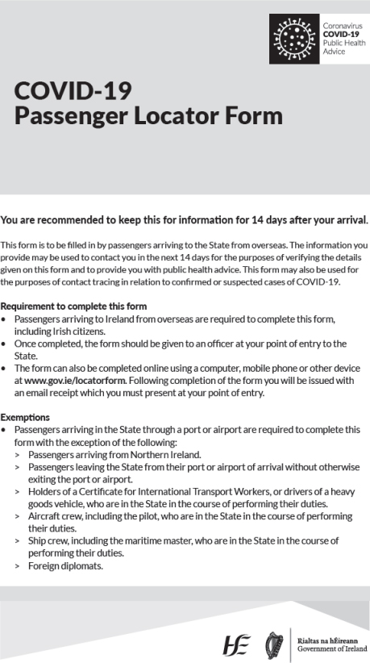

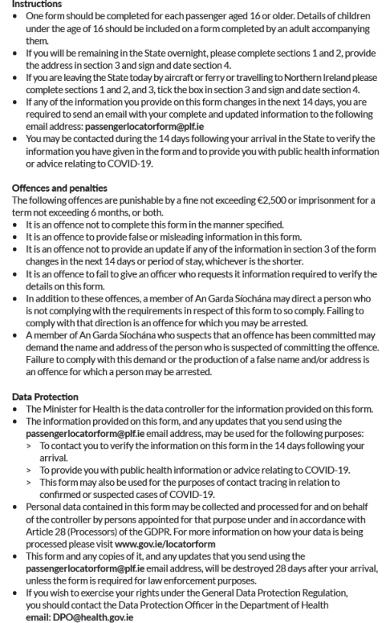

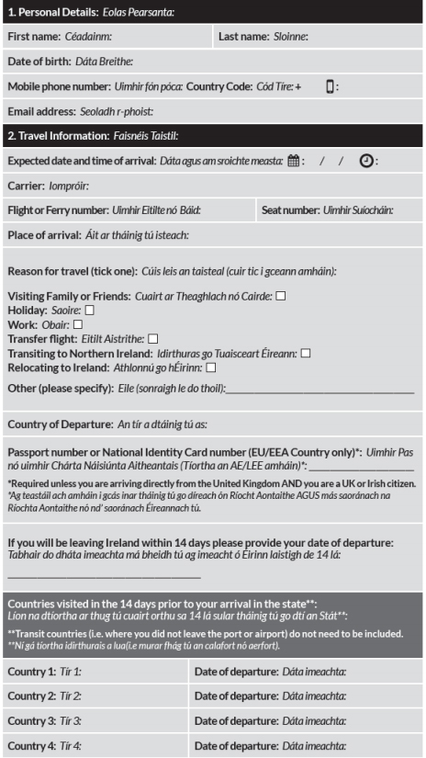

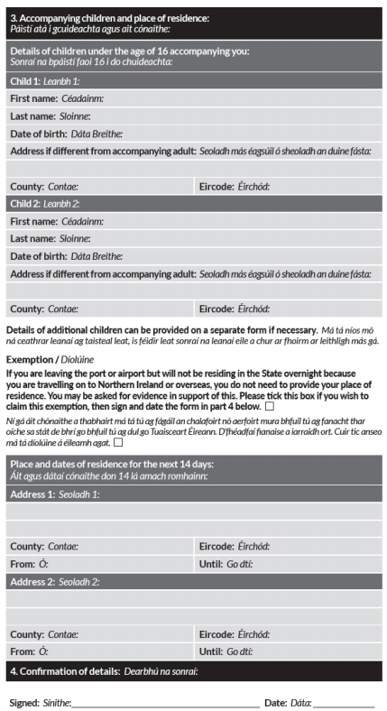

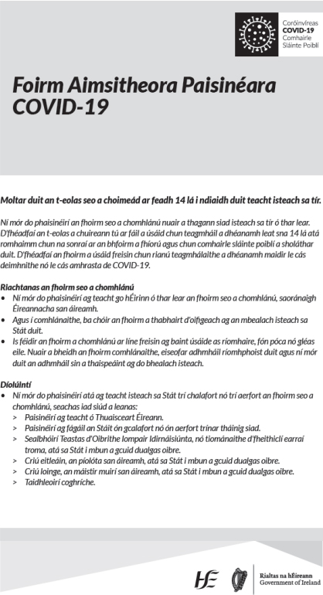

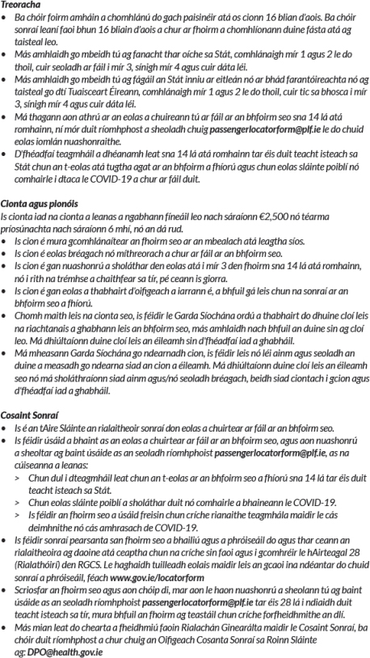

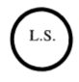

GIVEN under my Official Seal, 24 May, 2020.

SIMON HARRIS, Minister for Health.

EXPLANATORY NOTE  
(This note is not part of the Instrument and does not purport to be a legal interpretation.)

These Regulations, made under section 31A of the Health Act 1947 (inserted by section 10 of the Health (Preservation and Protection and other Emergency Measures in the Public Interest) Act 2020), provide for the imposition of a requirement that international passengers (including Irish citizens) arriving in the State at a port or airport from a place outside the State complete a COVID- 19 Passenger Locator Form for the purposes of recording and verifying information regarding their contact details and place of residence for a period of up to 14 days following arrival.

# **Table of Regulations amending the Temporary Requirements (COVID-19 Passenger Locator Form) Regulations**

|  |  |  |  |  |  |  |  |  |  |  |  |  |  |  |  |  |  |  |  |  |  |  |  |  |  |  |  |  |  |  |
| --- | --- | --- | --- | --- | --- | --- | --- | --- | --- | --- | --- | --- | --- | --- | --- | --- | --- | --- | --- | --- | --- | --- | --- | --- | --- | --- | --- | --- | --- | --- |
| |  |  |  | | --- | --- | --- | | **Title** | **Date made** | **Iris Oifigiúil** | | S.I. No. 217/2020 – Health Act 1947 (Section 31A – Temporary Requirements) (Covid-19 Passenger Locator Form) (Amendment) Regulations 2020 | 17/06/2020 | 19/06/2020 | | S.I. No. 243/2020 – Health Act 1947 (Section 31A – Temporary Requirements) (Covid-19 Passenger Locator Form) (Amendment) (No. 2) Regulations 2020 | 8/07/2020 | 10/07/2020 | | S.I. No. 251/2020 – Health Act 1947 (Section 31A – Temporary Requirements) (COVID-19 Passenger Locator Form) (Amendment) (No. 3) Regulations 2020. | 17/07/2020 | 21/07/2020 | | S.I. No. 294/2020 – Health Act 1947 (Section 31A – Temporary Requirements) (COVID-19 Passenger Locator Form) (Amendment) (No. 4) Regulations 2020 | 7/08/2020 | 11/08/2020 | | S.I. No. 304/2020 – Health Act 1947 (Section 31A – Temporary Requirements) (COVID-19 Passenger Locator Form) (Amendment) (No. 5) Regulations 2020 | 15/08/2020 | 18/08/2020 | | S.I. No. 314/2020 – Health Act 1947 (Section 31A – Temporary Requirements) (COVID-19 Passenger Locator Form) (Amendment) (No. 6) Regulations 2020 | 22/08/2020 | 25/08/2020 | |  |  |  | |  |  |  | |  |  |  | |

# ****S.I. No. 244/2020 - Health Act 1947 (Section 31A -Temporary Restrictions) (Covid-19) (Face Coverings on Public Transport) Regulations 2020****

*Notice of the making of this Statutory Instrument was published in “Iris Oifigiúil” of 14th July, 2020.*

I, STEPHEN DONNELLY, Minister for Health, in exercise of the powers conferred on me by sections 5 and 31A (inserted by section 10 of the Health (Preservation and Protection and other Emergency Measures in the Public Interest) Act 2020 (No. 1 of 2020)) of the Health Act 1947 (No. 28 of 1947) and -

(a)  having regard to the immediate, exceptional and manifest risk posed to human life and public health by the spread of Covid-19 and to the matters specified in subsection (2) of section 31A, and

(b)  having consulted with the Minister for Transport, Tourism and Sport and the Minister for Justice and Equality,

hereby make the following regulations:

**Citation and commencement**

1. (1) These Regulations may be cited as the Health Act 1947 (Section 31A – Temporary Restrictions) (Covid-19) (Face Coverings on Public Transport) Regulations 2020.

(2) These Regulations shall come into operation on the 13th day of July 2020.

**Operation of Regulations**

2. These Regulations shall remain in operation until the 5th day of October 2020.

**Definitions**

3. In these Regulations -

“Act of 2008” means the Dublin Transport Authority Act 2008 (No. 15 of 2008);

“face covering” means a covering of any type which when worn by a person covers the person’s nose and mouth;

“public passenger transport service” has the same meaning it has in the Act of 2008;

“public transport operator” has the same meaning it has in the Act of 2008;

“public transport vehicle” means a vehicle by means of which a public passenger transport service is provided;

“reasonable excuse” shall be construed in accordance with Regulation 6;

“relevant geographical location” means a geographical location to which an affected areas order applies;

“relevant person” has the meaning assigned to it by Regulation 4;

“travel by public transport vehicle” includes boarding a public transport vehicle.

**Relevant person**

4. The following persons (each of whom, in these Regulations, is referred to as a “relevant person”) are specified as relevant persons for the purposes of these Regulations:

(a)  any officer, employee or agent of a public transport operator who is –

(i)  in, on, or boarding a public transport vehicle owned or operated by that operator, and

(ii)  acting in the course of his or her duty as such officer, employee or agent in connection with the provision of a public passenger transport service on behalf of that operator;

(b)  any officer, employee or agent of the National Transport Authority who is –

(i)  in, on, or boarding a public transport vehicle owned or operated by a public transport operator, and

(ii)  acting in the course of his or her duty as such officer, employee or agent of the National Transport Authority.

**Requirement to wear face covering when travelling by public transport**

5. (1) A person shall not, without reasonable excuse, travel by public transport vehicle within a relevant geographical location without wearing a face covering.

(2) Paragraph (1) shall not apply -

(a)  to a person under the age of 13 years,

(b)  to a person driving a public transport vehicle from a compartment in which he or she is the sole occupant,

(c)  where there is a screen in a public transport vehicle which separates the driver of the vehicle from persons boarding or alighting from the vehicle, to a person driving the vehicle from behind that screen,

(d)  where there is not a screen in a public transport vehicle which separates the driver of the vehicle from persons boarding or alighting from the vehicle, to a person driving the vehicle during the periods when no person is boarding or alighting from the vehicle,

(e) to a member of the Garda Síochána in the course of performing his or her duties.

**Reasonable excuse**

6. Without prejudice to the generality of what constitutes reasonable excuse for the purposes of Regulation 5(1), a person has reasonable excuse if -

(a)  the person cannot put on, wear or remove a face covering -

(i)  because of any physical or mental illness, impairment, or disability, or

(ii)  without severe distress,

(b)  the person needs to communicate with a person who has difficulties communicating (in relation to speech, language or otherwise),

(c)  the person removes the face covering to provide emergency assistance or to provide care or assistance to a vulnerable person,

(d)  the person removes the face covering to avoid harm or injury, or the risk of harm or injury,

(e)  the person removes the face covering in order to, and only for the time required to, take medication.

**Powers of relevant person**

7. (1) Where a relevant person reasonably believes that a person travelling by public transport vehicle (in this Regulation referred to as a “passenger”) is not wearing a face covering in accordance with Regulation 5, he or she may do any of the following:

(a)  request the passenger to wear a face covering;

(b)  refuse the passenger entry to a public transport vehicle;

(c)  request the passenger to alight from a public transport vehicle.

(2) Before exercising a power under paragraph (1) in respect of a passenger, a relevant person shall give the passenger an opportunity to provide reasonable excuse and may request the passenger to provide such information as the relevant person considers necessary to determine whether or not the passenger has reasonable excuse.

(3) Notwithstanding paragraph (2), the onus shall be on a passenger to establish, to the satisfaction of the relevant person, that he or she has reasonable excuse.

(4) A passenger shall comply with a request or refusal under paragraph (1).

(5) Paragraph (4) is a penal provision for the purposes of section 31A of the Health Act 1947 (No. 28 of 1947).



GIVEN under the Official Seal of the Minister for Health, 10 July, 2020.

STEPHEN DONNELLY, Minister for Health.

EXPLANATORY NOTE  
(This note is not part of the Instrument and does not purport to be a legal interpretation.)

These Regulations provide that members of the public shall not, without reasonable excuse, travel by public transport without wearing a face covering. Public transport under the Regulations encompasses all bus and rail services provided under contract with the National Transport Authority (NTA), LUAS services and commercial bus services licensed by the NTA.

It is an offence not to comply with a request by a relevant person to wear a face covering. It is also an offence not to comply where a relevant person refuses entry to a public transport vehicle or where a relevant person requests a person to alight from a public transport vehicle. Relevant persons under the Regulations are officers, employees or agents of public transport operators or the National Transport Authority.

The Regulations do not apply to children aged under 13 years and do not apply, in certain circumstances, to drivers of public transport vehicles.

# **Table of Regulations amending the Temporary Restrictions (COVID-19) (Face Coverings on Public Transport) Regulations**

|  |  |  |  |  |  |  |  |  |  |  |  |  |
| --- | --- | --- | --- | --- | --- | --- | --- | --- | --- | --- | --- | --- |
| |  |  |  | | --- | --- | --- | | **Title** | **Date made** | **Iris Oifigiúil** | |  |  |  | |  |  |  | |  |  |  | |

# **S.I. No. 295/2020 - Health Act 1947 (Section 31A -Temporary Restrictions) (Covid-19) (Relevant Counties) Regulations 2020**

Notice of the making of this Statutory Instrument was published in “Iris Oifigiúil” of 11th August, 2020.

I, Stephen Donnelly, Minister for Health, in exercise of the powers conferred on me by sections 5 and 31A (inserted by section 10 of the Health (Preservation and Protection and other Emergency Measures in the Public Interest) Act 2020 (No. 1 of 2020)) of the Health Act 1947 (No. 28 of 1947) and -

(a)  having regard to the immediate, exceptional and manifest risk posed to human life and public health by the spread of Covid-19 and to the matters specified in subsection (2) of section 31A, and

(b)  having consulted with the Minister for Justice and Equality,

hereby make the following regulations:

Citation and commencement

1. (1) These Regulations may be cited as the Health Act 1947 (Section 31A – Temporary Restrictions) (Covid – 19) (Relevant Counties) Regulations 2020.

(2) These Regulations shall come into operation on the 8th day of August 2020.

Operation of Regulations

2. (1) These Regulations shall remain in operation until the 7th day of September 2020.

(2) These Regulations shall have effect notwithstanding any other Regulation made under section 31A of the Act of 1947 that conflicts with these Regulations.

Interpretation

3. In these Regulations -

“Act of 1947” means the Health Act 1947 (No. 28 of 1947);

“Act of 2001” means the Local Government Act 2001 (No. 37 of 2001);

“applicable person” means a person whose place of residence is located within a relevant county;

“county” has the same meaning as it has in section 10 (amended by section 12 of the Local Government Reform Act 2014 (No. 1 of 2014)) of the Act of 2001, being a Local Government Area that is listed as a County in Schedule 5 to the Act of 2001;

“county of residence”, in relation to an applicable person, means the county in which his or her place of residence is situated;

“place of residence”, in relation to an applicable person, means –

(a)  the premises that comprise the person’s home, or

(b)  if the person does not have a home or is not residing in his or her home, such other premises, if any, at which he or she is currently residing, whether on a permanent or temporary basis;

“relevant county” means a county that is –

(a)  listed in Schedule 1, and

(b)  located in a relevant geographical location;

“relevant geographical location” means a geographical location to which an affected areas order applies;

“vulnerable person” means -

(a)  a person who normally requires assistance in carrying out his or her daily activities,

(b)  a person who, although not normally requiring assistance in carrying out his or her daily activities, requires such assistance because he or she is -

(i)  particularly susceptible to the risk posed to health by Covid-19, or

(ii)  not in a position to leave his or her place of residence due to reasons related to the spread of Covid-19 or otherwise,

or

(c)  a child.

Restriction of movement relating to relevant counties

4. (1) An applicable person shall not travel from his or her county of residence to another county without reasonable excuse.

(2) Subject to paragraph (3), a person other than an applicable person shall not travel to a relevant county from any other county, including another relevant county, without reasonable excuse.

(3) Paragraph (2) shall not apply to a person who travels to a relevant county in a vehicle, where the person subsequently leaves the relevant county without having exited the vehicle for any reason other than to refuel the vehicle or for reasons of an emergency.

(4) Without prejudice to the generality of what constitutes a reasonable excuse for the purposes of paragraphs (1) and (2), a reasonable excuse for travelling from the county of residence in the case of an applicable person, or travelling to a relevant county in the case of a person other than an applicable person, includes travelling in order to -

(a)  work, comply with a contract of employment or contract for services, or otherwise engage in work or employment,

(b)  farm, carry out agricultural activities, or assist in farming or carrying out agricultural activities,

(ba) attend, for educational reasons, a school, university, higher education institution or other education and training facility or to accompany to such school, university, higher education institution or other education and training facility, any other person residing with the person, or a vulnerable person,

(bb) access crèche or other childcare facilities

(c)  attend a medical or dental appointment, or accompany, to such an appointment, any other person residing with the person or a vulnerable person,

(d)  seek essential medical, health or dental assistance for the person, for any other person residing with the person, or for a vulnerable person,

(e)  donate blood or accompany any other person residing with the person to donate blood,

(f)  seek veterinary assistance,

(g)  attend to vital family matters (including providing care to vulnerable persons),

(h)  attend a funeral,

(i)  fulfil a legal obligation (including attending court, satisfying bail conditions, or participating in ongoing legal proceedings), attend a court office where required, initiate emergency legal proceedings or execute essential legal documents,

(j)  if the person is a parent or guardian of a child, or a person having a right of access to a child, give effect to arrangements for access to the child by -

(i)  the person, or

(ii)  another person who is -

(I)  a parent or guardian of the child, or

(II)  a person having a right of access to the child,

(k)  in the case of a minister of religion or priest (or any equivalent thereof in any religion) -

(i)  lead worship or services remotely through the use of information and communications technology,

(ii)  minister to the sick, or

(iii)  conduct funeral services,

(l)  move to another residence where, in all the circumstances of the case, such movement is reasonably necessary, or

(m)  provide emergency assistance, avoid injury or illness, or escape a risk of harm, whether to the person or to another person.

Restrictions on events and funerals

5. (1) A person shall not organise, or cause to be organised, an event for cultural, entertainment, sporting or community reasons to be held in a relevant county other than where one or more of the following applies -

(i)  in the case of an event to be held indoors, the maximum number of persons attending, or proposed to attend, the event (for whatever reason) does not exceed 6 persons,

(ii)  in the case of an event to be held outdoors, the maximum number of persons attending, or proposed to attend, the event (for whatever reason) does not exceed 15 persons,

(iii)  the person so organising the event, or so causing the event to be organised, takes all reasonable steps to ensure that the number of persons attending, or proposed to attend, the event (for whatever reason) does not exceed, in the case of an indoor event, 6 persons, and in the case of an outdoor event, 15 persons.

(2) A person shall not organise, or cause to be organised, a funeral to be held in a relevant county other than where the number of people excluding a minister of religion or priest (or any equivalent thereof in any religion), attending the funeral does not exceed 25.

(3) Paragraph (1) is a penal provision for the purposes of section 31A of the Act of 1947.

Restriction of movement of applicable persons in relation to exercise and social or recreational purposes

6. (1) Subject to paragraphs (2) to (4), an applicable person shall not engage or otherwise participate in a relevant activity outside his or her place of residence (in this Regulation referred to as the “relevant residence”).

(2) An applicable person may, within the county in which the relevant residence is situated –

(a)  exercise outdoors alone,

(b)  exercise outdoors –

(i)  with other persons residing in the relevant residence,

(ii)  with a maximum of 14 other persons who do not reside in the relevant residence, or

(iii)  with a maximum of 14 other persons, where one or more of such other persons resides in the relevant residence and one or more of such other persons does not so reside,

(c)  go out alone for recreational purposes,

(d)  gather indoors for social or recreational purposes together with –

(i)  other persons residing in the relevant residence,

(ii)  a maximum of 5 other persons who do not reside in the relevant residence, provided that those persons, together, represent no more than three places of residence or

(iii)  a maximum of 5 other persons, where one or more of such other persons resides in the relevant residence and one or more of such other persons does not so reside, provided that those persons, together, represent no more than three places of residence, or

(e)  gather outdoors for social or recreational purposes together with –

(i)  other persons residing in the relevant residence,

(ii)  a maximum of 14 other persons who do not reside in the relevant residence, or

(iii)  a maximum of 14 other persons, where one or more of such other persons resides in the relevant residence and one or more of such other persons does not so reside.

(3) An applicable person may engage or otherwise participate in training relating to a sport, where –

(a)  the person, in respect of the sport concerned –

(i)  is in receipt of financial support provided by Sport Ireland under the scheme commonly known and referred to as the Sport Ireland International Carding Scheme,

(ii)  competes at a senior level and is a participant in a high performance training programme of the national governing body of the sport, which body receives, from Sport Ireland, financial support commonly known and referred to as the Sport Ireland High Performance Programme Funding,

(iii)  is a member of an inter-county team, at senior or minor level, in a competition organised by the organisations commonly known and referred to as the Gaelic Athletic Association, the Ladies Gaelic Football Association or the Camogie Asociation, or

(iv)  is a professional sportsperson who receives payment for training and playing the sport under a contract of employment with a soccer club or the rugby football organisation commonly known and referred to as the Irish Rugby Football Union,

(b)  the training is supervised by a member of staff of Sport Ireland, a coach or a trainer, and

(c)  it is in the best interests of the ongoing improvement, maintenance or enhancement of the person’s performance in that sport to undergo such training.

(4) In this Regulation –

“relevant activities” means activities that are engaged in or participated in solely for -

(a)  social or recreational purposes, or

(b)  the purposes of exercise;

“social or recreational purposes” includes leisure or holiday purposes.

Carrying on or provision of relevant business or service

7. (1) A specified person shall take all reasonable steps to ensure that members of the public are not permitted, or otherwise granted, access to a premises in a relevant county, or to a part of such a premises, where a relevant business or service is carried on or otherwise provided.

(2) Paragraph (1) is a penal provision for the purposes of section 31A of the Act of 1947.

(3)  For the avoidance of doubt, paragraph (1) does not prohibit -

(a)  the filming or other recording of performances in a theatre, concert hall, museum or art gallery, without an audience present, for the purposes of broadcasting such performances on the internet, radio or television,

(b)  the holding of horseracing or greyhound racing at a racecourse, where no persons are in attendance at the racecourse solely for the purposes of spectating such racing, or

(c)  the use of a premises, or part of a premises, for the purposes of a meeting of a local authority (within the meaning of the Act of 2001).

* + 1. In this Regulation –

“relevant business or service” means a business or service of a type specified in Schedule 2;

“specified person”, in relation to a relevant business or service, means –

(a)  the occupier,

(b)  the manager, or

(c)  any other person for the time being in charge,

of the premises, or part of the premises, where the relevant business or service is carried on or otherwise provided.

**SCHEDULE 1**

*Regulation 3*

RELEVANT COUNTIES

1. The county of Kildare.

**SCHEDULE 2**

*Regulation 7*

RELEVANT BUSINESSES OR SERVICES

1. Cinemas, other than outdoor cinemas at which persons attending a screening do so in motor vehicles and remain in the vehicles without exiting the motor vehicles for the duration of such attendance.

2. Theatres and concert halls. 3. Museums.

4. Art galleries, other than privately-owned art galleries offering artworks for sale.

5. Circuses.

6. Nightclubs and discotheques, including those licenced under the Public Dance Halls Act 1935 (No. 2 of 1935).

7. Bingo halls.

8. Casinos and Private Members’ Clubs at which gambling activities are carried out.

9. Licensed bookmakers (within the meaning of the Betting Act 1931 (No. 27 of 1931)).

10. Ice skating rinks.

11. Roller skating rinks.

12. Aquariums.

13. Indoor leisure facilities, including bowling alleys, amusement arcades, dance studios, soft play areas and other indoor children’s play areas.

14. The following facilities, other than insofar as they are necessary for athletic use and training by persons specified in Regulation 6(3), or the coaching and support personnel of such persons:

(a)  swimming pools (whether indoor or outdoor);

(b)  indoor fitness facilities;

(c)  indoor gymnasiums;

(d)  indoor sports facilities.

15. Funfairs, including funfairs within the meaning of the Gaming and Lotteries Act 1956 (No. 2 of 1956).

16. Amusement halls licensed in accordance with the Gaming and Lotteries Act 1956 (No. 2 of 1956).

17. Amusement parks and theme parks.

18. Hotels or similar accommodation services, other than insofar as they are providing -

(a) essential accommodation (including accommodation for homeless persons and persons in direct provision and persons who are unable to reside in their usual place of residence due to reasons related to the spread of Covid-19 or otherwise),

(b) accommodation for a person that is necessary for the purposes of his or her work or employment,

(c) accommodation for a person that is necessary to permit or enable him or her to attend a funeral,

(d) accommodation for a person that is necessary to permit or enable him or her to fulfil legal obligations,

(e) accommodation for a person that is necessary to permit or enable him or her to receive medical or dental treatment,

(f) accommodation for a person that is necessary for vital family reasons, or

(g) accommodation which was being provided at the time of the coming into operation of these Regulations, for the remainder of the period of time for which such accommodation was booked, providing that the provision of such accommodation is continuous.

19. Outlets selling food or beverages (including an outlet in relation to which an on-licence (within the meaning of the Public Health (Alcohol) Act 2018 (No. 24 of 2018) applies) whether on a retail or wholesale basis and whether in a non-specialised or specialised outlet, other than –

(a)  insofar as they sell food or beverages on a takeaway basis or for consumption off the premises,

(b)  insofar as they sell food or beverages for consumption in an area of part of the premises the entirety of which is situated outdoors, or

(c)  staff canteens operating for the exclusive use of persons working in, or at, a particular premises.

20. Auctions, other than livestock marts (within the meaning of the Animal Health and Welfare (Livestock Marts) Regulations 2018 (S.I. No. 128 of 2018)).

21. Racecourses.

22. Sports stadiums, campuses and sports training facilities other than insofar as –

(a)  they are available free of charge for informal and recreational use by members of the public,

(b)  their operation is necessary for athletic use and training by persons specified in Regulation 6(3) or by the coaching and support personnel of such persons, or

(c) their operation is necessary for the purposes of organising an outdoor event for sporting or educational reasons in accordance with Regulation 6, or for holding such an event.



GIVEN under my Official Seal, 8 August, 2020.

STEPHEN DONNELLY, Minister for Health.

EXPLANATORY NOTE

(This note is not part of the Instrument and does not purport to be a legal interpretation.)

These Regulations provide for certain temporary restrictions in County Kildare, County Laois and County Offaly because of Covid-19. The Regulations remain in operation until 23 August 2020.

# **Table of Regulations amending the Temporary Restrictions (COVID-19) (Relevant Counties) Regulations**

|  |  |  |  |  |  |  |  |  |  |  |  |  |
| --- | --- | --- | --- | --- | --- | --- | --- | --- | --- | --- | --- | --- |
| |  |  |  | | --- | --- | --- | | **Title** | **Date made** | **Iris Oifigiúil** | | S.I. No. 297 Health Act 1947 (Section 31A – Temporary Restrictions) (COVID-19) (Relevant Counties) (Amendment) Regulations 2020 | 9/08/2020 | 11/08/2020 | | S.I. No. 315 Health Act 1947 (Section 31A – Temporary Restrictions) (COVID-19) (Relevant Counties) (Amendment) (No. 2) Regulations 2020 | 22/08/2020 | 25/08/2020 | |  |  |  | |

# **S.I. No. 296/2020 - Health Act 1947 (Section 31A -Temporary Restrictions) (Covid-19) (Face Coverings in Certain Premises and Businesses) Regulations 2020**

*Notice of the making of this Statutory Instrument was published in “Iris Oifigiúil” of 11th August, 2020.*

I, Stephen Donnelly, Minister for Health, in exercise of the powers conferred on me by sections 5 and 31A (inserted by section 10 of the Health (Preservation and Protection and other Emergency Measures in the Public Interest) Act 2020 (No. 1 of 2020)) of the Health Act 1947 (No. 28 of 1947) and –

(a) having regard to the immediate, exceptional and manifest risk posed to human life and public health by the spread of Covid-19 and to the matters specified in subsection (2) of section 31A, and

(b) having consulted with the Minister for Business, Enterprise and Innovation and the Minister for Justice and Equality,

hereby make the following regulations:

Citation and commencement

1. (1) These Regulations may be cited as the Health Act 1947 (Section 31A – Temporary Restrictions) (Covid-19) (Face Coverings in Certain Premises and Businesses) Regulations 2020.

(2) These Regulations shall come into operation on the 10th day of August 2020

**Operation of Regulations**

2. These Regulations shall remain in operation until the 5th day of October 2020.

Definitions

3. In these Regulations -

“face covering” means a covering of any type which when worn by a person covers the person’s nose and mouth;

“reasonable excuse” shall be construed in accordance with Regulation 5;

“relevant geographical location” means a geographical location to which an affected areas order applies;

“relevant premises” means an indoor premises, or a part of such a premises, to which the public has access -

(a) where goods are sold directly to the public

(b) that is specified in Part A of the Schedule, or

(c) in which a service specified in Part B of the Schedule is provided or a business specified in Part B of the Schedule is carried on,

but does not include an indoor premises or a part of such a premises –

(i) that is a post office, credit union or bank,

(ii) in which the principal activity is the sale of food or beverages for consumption on the premises, or

(iii) in which the principal activity is the provision of medical or dental services or other healthcare services (other than retail pharmacy businesses (within the meaning of the Pharmacy Act 2007 (No. 20 of 2007)), optician and optometrist outlets and outlets providing hearing test services or selling hearing aids and appliances);

page2image56816000

“responsible person”, in relation to a relevant premises, means each of the following:

(a)  the occupier of the relevant premises,

(b)  the manager of the relevant premises, and

(c) any other person for the time being in charge of the relevant premises;

“worker”, in relation to a relevant premises, means a person working at the relevant premises under a contract of employment or a contract for service.

Requirement to wear face covering

4. (1) A person shall not, without reasonable excuse, enter or remain in a relevant premises in a relevant geographical location without wearing a face covering.

(2) Paragraph (1) shall not apply to –

(a) a person under the age of 13 years

(b) a responsible person or a worker where -

(i) there is a screen that separates the responsible person or worker from other persons, or

(ii) the responsible person or worker takes all reasonable steps to maintain a distance of at least two metres between himself or herself and other persons,

(c) a member of the Garda Síochána in the course of performing his or her duties.

(3) Paragraph (1) is a penal provision for the purposes of section 31A of the Health Act 1947 (No. 28 of 1947).

(4) A responsible person shall take reasonable steps to engage with persons entering or in the relevant premises to inform them of the requirements of paragraph (1) and to promote compliance with those requirements.

Reasonable excuse

1. Without prejudice to the generality of what constitutes reasonable excuse for the purposes of Regulation 4(1), a person has reasonable excuse if -

(a) the person cannot put on, wear or remove a face covering –

(i) because of any physical or mental illness, impairment or disability, or

(ii) without severe distress,

(b) the person needs to communicate with a person who has difficulties communicating (in relation to speech, language or otherwise),

(c) the person removes the face covering to provide emergency assistance or to provide care or assistance to a vulnerable person,

(d) the person removes the face covering to avoid harm or injury, or the risk of harm or injury,

(e) the person removes the face covering in order to, and only for the time required to, take medication,

(f) the person removes the face covering at the request of a responsible person, or of a worker, in order to enable him or her to ascertain the person’s age by reference to photographic identification for the purposes of the sale of goods or services in respect of which there is a minimum age requirement or where the responsible person, or worker, has lawful authority to verify the person’s identity, or

(g) the person removes the face covering at the request of a responsible person, or of a worker, in order to assist the responsible person or worker to provide him or her with healthcare or healthcare advice.

Schedule

Regulation 3

Part A

Specified Premises

1. Shopping centres.
2. Libraries.
3. Cinemas and cinema complexes.
4. Theatres.
5. Concert halls.
6. Bingo halls.
7. Museums.

Part B  
Specified Services and Businesses

1. Cosmetic nail care or nail styling.
2. Hair care or hair styling.
3. Tattoo and piercing services.
4. Travel agents and tour operators.
5. Laundries and dry cleaners.
6. Licensed bookmakers (within the meaning of the Betting Act 1931 (No. 27 of 1931)).



GIVEN under my Official Seal, 8 August, 2020.

STEPHEN DONNELLY, Minister for Health.

EXPLANATORY NOTE  
(This note is not part of the Instrument and does not purport to be a legal interpretation.)

These Regulations require the wearing of face coverings in certain premises. A person shall not, without reasonable excuse, enter or remain in a premises where goods are sold directly to the public or a premises set out in the Schedule to the Regulations, without wearing a face covering.

The Regulations do not apply to children aged under 13 years.

# **Table of Regulations amending the Temporary Restrictions (COVID-19) (Face Covering in Certain Premises and Businesses) Regulations**

|  |  |  |  |  |  |  |  |  |  |  |  |  |
| --- | --- | --- | --- | --- | --- | --- | --- | --- | --- | --- | --- | --- |
| |  |  |  | | --- | --- | --- | | **Title** | **Date made** | **Iris Oifigiúil** | |  |  |  | |  |  |  | |  |  |  | |