The information provided in this document is not legal advice or professional advice of any other kind, and should not be considered to be such, or relied or acted upon in that regard. If you need legal or other professional advice, you should consult a suitably qualified person.
To the extent permitted by law, Trinity College Dublin and the authors of this document, and their respective servants or agents, assume and accept no responsibility for, and give no guarantees, undertakings or warranties concerning, the accuracy, clarity, comprehensiveness, completeness, timeliness, fitness-for-purpose, up-to-date nature, reliability, or otherwise, of the information provided in this document, and do not accept any liability whatsoever in respect of, or arising from, any errors or omissions or any reliance on, or use of, such information.
Whilst we have taken reasonable care in preparing this document, to the extent permitted by law, we accept no responsibility for any loss or damage claimed to arise from any reliance on, or action taken by any person or organisation, wherever they are based, as a result, direct or otherwise, of, information contained in, or accessed through, this document, whether such information is provided by us or by a third party.
If you identify any errors or omissions in this document, please email us at covid.observatory@tcd.ie.
30 June 2020

Table of Contents
S.I. No. 234/2020 - Health Act 1947 (Section 31A -Temporary Restrictions) (Covid-19) (No. 3) Regulations 2020 2
Table of Regulations amending the Temporary Restrictions (No. 3) Regulations 5
S.I. No. 120/2020 - Health Act 1947 (Affected Areas) Order 2020 6
Table of Regulations amending the Affected Areas Order 7
S.I. No. 181/2020 - Health Act 1947 (Section 31A -Temporary Requirements) (Covid-19 Passenger Locator Form) Regulations 2020 8
Table of Regulations amending the Temporary Requirements (COVID-19 Passenger Locator Form) Regulations 21
S.I. No. 244/2020 - Health Act 1947 (Section 31A -Temporary Restrictions) (Covid-19) (Face Coverings on Public Transport) Regulations 2020 22
Table of Regulations amending the Temporary Restrictions (COVID-19) (Face Coverings on Public Transport) Regulations 26

S.I. No. 234/2020 - Health Act 1947 (Section 31A -Temporary Restrictions) (Covid-19) (No. 3) Regulations 2020
Notice of the making of this Statutory Instrument was published in “Iris Oifigiúil” of 30th June, 2020.
The Minister for Health, in exercise of the powers conferred on him by sections 5 and 31A (inserted by section 10 of the Health (Preservation and Protection and other Emergency Measures in the Public Interest) Act 2020 (No. 1 of 2020)) of the Health Act 1947 (No. 28 of 1947) and –
(a) having regard to the immediate, exceptional and manifest risk posed to human life and public health by the spread of Covid-19 and to the matters specified in subsection (2) of section 31A, and
(b) having consulted with the Minister for Finance, the Minister for Public Expenditure and Reform, the Minister for Justice and Equality, the Minister for Transport, Tourism and Sport and the Minister for Business, Enterprise and Innovation,
hereby makes the following regulations:
Citation and commencement
1. (1) These Regulations may be cited as the Health Act 1947 (Section 31A – Temporary Restrictions) (Covid-19) (No. 3) Regulations 2020.
(2) These Regulations shall come into operation on the 10th day of August 2020.
Operation of Regulations
2. These Regulations shall remain in operation until the 20th day of July 2020.
Revocation
3. The Health Act 1947 (Section 31A – Temporary Restrictions) (Covid- 19) (No. 2) Regulations 2020 (S.I. No. 206 of 2020) are revoked.
Definitions
4. In these Regulations –
“Act of 1947” means the Health Act 1947 (No. 28 of 1947);
“relevant geographical location” means a geographical location to which an affected areas order applies.
Restriction on events
5. (1) Subject to paragraph (2), a person shall not organise, or cause to be organised, an event for cultural, entertainment, recreational, sporting, social, community or educational reasons in a relevant geographical location other than where one or more of the following applies:
- (a) in the case of an indoor event, the maximum number of persons attending, or proposed to attend, the event (for whatever reason) does not exceed 50 persons;
- (b) in the case of an outdoor event, the maximum number of persons attending, or proposed to attend, the event (for whatever reason) does not exceed 200 persons;
- (c) the person so organising, or so causing to be organised, the event takes all reasonable steps to ensure that the number of persons attending, or proposed to attend, the event (for whatever reason) does not exceed, in the case of an indoor event, 50 persons, and in the case of an outdoor event, 200 persons.
(2) This Regulation shall not apply to an event held, or proposed to be held, in a private dwelling.
(3) Paragraph (1) is a penal provision for the purposes of section 31A of the Act of 1947.
Carrying on or provision of certain businesses or services
6. (1) A relevant person shall take all reasonable steps to ensure that members of the public are not permitted, or otherwise granted, access to a premises in a relevant geographical location, or to a part of such premises, where a business or service of a type specified in paragraph (2) is carried on or otherwise provided.
(2) The following types of businesses and services are specified for the purposes of paragraph (1):
(a) a nightclub or discotheque, including those licenced under the Public Dance Halls Act 1935 (No. 2 of 1935);
(b) a casino or Private Members’ Club at which gambling activities are carried out and which is operated on a commercial basis;
(c) any other business or service that is selling or supplying intoxicating liquor for consumption on the premises and that, but for this Regulation, is otherwise permitted by law to do so, other than where such intoxicating liquor is –
(i) ordered by or on behalf of the member of the public being permitted, or otherwise granted, access to the premises, at the same time as a substantial meal is so ordered, during the meal or after the meal has ended, and
(ii) consumed by that member during the meal or after the meal has ended.
(3) Paragraph (1) is a penal provision for the purposes of section 31A of the Act of 1947.
(4) In this Regulation –
“relevant person”, in relation to a premises, or part of such premises, where a business or service of a type specified in paragraph (2) is carried on or otherwise provided, means –
(a) the occupier,
(b) the manager, or
(c) any other person for the time being in charge,
of the premises, or part of the premises, concerned;
“substantial meal” means a meal –
(a) such as might be expected to be served as a main midday or main evening meal or as a main course at either such meal, and
(b) that is of a kind, having regard to all the circumstances, for which it would be reasonable to charge a sum that is not less than €9.
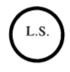
GIVEN under the Official Seal of the Minister for Health, 26 June, 2020.
SIMON HARRIS, Minister for Health.

Table of Regulations amending the Temporary Restrictions (No. 3) Regulations
Title | Date made | Iris Oifigiúil
S.I. No. 252/2020 – Health Act 1947 (Section 31A – Temporary Restrictions) (Covid-19) (No. 3) (Amendment) Regulations 2020 | 18/07/2020 | 21/07/2020

S.I. No. 120/2020 - Health Act 1947 (Affected Areas) Order 2020
Notice of the making of this Statutory Instrument was published in
“Iris Oifigiúil” of 10th April, 2020.
The Minister for Health, in the exercise of the powers conferred on him by section 31B of the Health Act 1947 (No. 28 of 1947), having regard to the matters specified in section 31A(2) of that Act and to the advice of the Chief Medical Officer of the Department of Health and having consulted with the Minister for Justice and Equality, the Minister for Finance and the Minister for Public Expenditure and Reform, hereby orders as follows:
1. This Order may be cited as the Health Act 1947 (Affected Areas) Order 2020.
2. It is hereby declared that the State (being every area or region thereof) is an area where there is known or thought to be sustained human transmission of Covid-19.
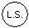
GIVEN under the Official Seal of the Minister for Health,
7 April, 2020.
SIMON HARRIS,
Minister for Health.
EXPLANATORY NOTE
(This note is not part of the Instrument and does not purport to be a legal interpretation.)
This Order declares that the State (being every area or region thereof) is an area where there is known or thought to be sustained human transmission of Covid-19.

Table of Regulations amending the Affected Areas Order
Title | Date made | Iris Oifigiúil

S.I. No. 181/2020 - Health Act 1947 (Section 31A -Temporary Requirements) (Covid-19 Passenger Locator Form) Regulations 2020
Notice of the making of this Statutory Instrument was published in “Iris Oifigiúil” of 26th May, 2020.
The Minister for Health, in exercise of the powers conferred on him by sections 5 and 31A (inserted by section 10 of the Health (Preservation and Protection and other Emergency Measures in the Public Interest) Act 2020 (No. 1 of 2020)) of the Health Act 1947 (No. 28 of 1947) and -
(a) having regard to the immediate, exceptional and manifest risk posed to human life and public health by the spread of Covid-19 and to the matters specified in subsection (2) of section 31A, and
(b) having consulted with the Minister for Foreign Affairs and Trade, the Minister for Justice and Equality, the Minister for Business, Enterprise and Innovation and the Minister for Transport, Tourism and Sport,
hereby makes the following regulations:
Citation and commencement
1. (1) These Regulations may be cited as the Health Act 1947 (Section 31A – Temporary Requirements) (Covid-19 Passenger Locator Form) Regulations 2020.
(2) These Regulations shall come into operation on the 28th day of May 2020.
Operation of Regulations
2. These Regulations shall remain in operation until the 10th day of August 2020.
Definitions
3. In these Regulations -
“airport” means any of the following airports:
(a) Cork Airport;
(b) Donegal Airport;
(c) Dublin Airport;
(d) Ireland West Airport;
(e) Kerry Airport;
(f) Shannon Airport;
(g) Waterford Airport;
“contact details”, in relation to an international passenger, means his or her
telephone number and email address;
“Covid-19 Passenger Locator Form” means the form set out in the Schedule;
“international passenger” means a person, other than a child, who arrives in the State at a port or airport from a place outside the State, but does not include:
(a) a person who arrives in the State from Northern Ireland;
(b) a person who arrives at the port or airport for the purposes of passing through that port or airport in order to travel to another state, and who does not leave the port or airport;
(c) an international transport worker who arrives in the State in the course of performing his or her duties;
(d) an aircraft pilot, other aircrew, maritime master or maritime crew who arrives in the State in the course of performing his or her duties;
(e) a person to whom the privileges and immunities conferred by -
(i) the Vienna Convention on Diplomatic Relations done at Vienna on the 18th day of April 1961, or
(ii) the Vienna Convention on Consular Relations done at Vienna on the 24th day of April 1963,
apply in the State;
(f) a person to whom the privileges and immunities conferred by an international agreement or arrangement apply in the State, pursuant to the Diplomatic Relations and Immunities Acts 1967 to 2006 or any other enactment;
“international transport worker” means a person -
(a) who holds a valid annex 3 certificate in accordance with the Communication from the Commission on the implementation of the Green Lanes under the Guidelines for border management measures to protect health and ensure the availability of goods and essential services1, or
(b) who is a driver of a heavy goods vehicle;
“place of residence”, in relation to an international passenger, means the place, or places, in the State at which he or she intends to reside during the relevant period;
“port” means any of the following ports:
(a) Cobh in the Port of Cork;
(b) Dublin Port;
(c) Killybegs Harbour;
(d) Port of Cork;
(e) Port of Galway;
(f) Port of Waterford;
(g) Rosslare EuroPort;
“relevant period”, in relation to an international passenger, means -
(a) the period of 14 days from the date on which he or she arrives in the State, or
(b) where the duration of his or her stay in the State is less than 14 days, the period of his or her stay;
“relevant person” has the meaning assigned to it by Regulation 4;
“responsible adult” means, in relation to a child who arrives in the State at a port or airport from a place outside the State, an international passenger who is travelling with the child and who is responsible, alone or jointly with another person, for that child for all or part of the journey by which the child arrives in the State.
Relevant persons
4. The following persons (each of whom, in these Regulations, is referred to as a “relevant person”) are specified as relevant persons for the purposes of these Regulations:
(a) officers of the Minister for Justice and Equality, being immigration officers appointed by that Minister under section 3 of the Immigration Act 2004 (No. 1 of 2004);
(b) persons appointed by the Health Service Executive under the programme commonly known as the Covid-19 Contact Management Programme.
Covid-19 Passenger Locator Form
5. (1) An international passenger shall -
(a) on or before his or her arrival in the State, complete a Covid-19 Passenger Locator Form -
(i) in respect of himself or herself, and
(ii) subject to paragraph (2), in respect of any child in relation to whom the international passenger is a responsible adult,
(b) on arrival in the State, present himself or herself to a relevant person, and
(c) give to the relevant person the Covid-19 Passenger Locator Form completed in accordance with paragraph (a).
(2) Where the requirement in paragraph (1)(a)(ii) applies to 2 or more international passengers, in relation to a child, that requirement shall be deemed to be complied with by all such international passengers where a Covid-19 Passenger Locator Form has been completed in respect of the child by any one of the international passengers.
(3) Where a relevant person suspects, with reasonable cause, that any person in an airport or port who has not completed a Covid-19 Passenger Locator Form is an international passenger, the relevant person may request that person to provide such information or documentation to the relevant person as he or she may reasonably require in order to ascertain whether or not the person is an international passenger.
(4) A person shall comply with a request under paragraph (3).
(5) Paragraphs (1) and (4) are penal provisions for the purpose of section 31A of the Health Act 1947 (No. 28 of 1947).
Provision of information to relevant person
6. (1) Where a relevant person considers it necessary to do so, he or she may request an international passenger to provide such information or documentation as may be required in order to verify any particular stated on a Covid-19 Passenger Locator Form provided by that international passenger.
(2) Where a relevant person suspects, with reasonable cause, that the information provided on a Covid-19 Passenger Locator Form is inaccurate, incomplete or misleading, he or she may request the international passenger who provided the information to clarify the information, or provide such further information or documentation as the relevant person may reasonably require to ensure that the form is completed accurately.
(3) A relevant person may, during a relevant period, request an international passenger to confirm -
(a) where the international passenger is currently residing, and
(b) where a child, in relation to whom the international passenger has completed a Covid-19 Passenger Locator Form, is currently residing.
(4) An international passenger shall comply with are quest under paragraph (1), (2) or (3).
(5) Subject to paragraph (6), where an international passenger, during a relevant period -
(a) takes up residence in a place other than the place of residence specified in the Covid-19 Passenger Locator Form,
(b) changes his or her contact details from those provided in the Covid-19 Passenger Locator Form, or
(c) is aware that a child in relation to whom he or she has completed a Covid-19 Passenger Locator Form has taken up residence in a place other than the place of residence specified in that form,
such that information provided in the Covid-19 Passenger Locator Form completed by the international passenger is no longer accurate, the international passenger shall make reasonable efforts to provide to a relevant person, in writing, accurate information as to the new place or contact details, or both, as the case may be.
(6) The information that is to be provided in accordance with paragraph (5) shall be provided to a relevant person by an international passenger -
(a) in the case of information specified in subparagraphs (5)(a) or (c), before the international passenger, or child as the case may be, has taken up residence in the new place, or as soon as practicable thereafter, or
(b) in the case of information specified in subparagraph (5)(b), as soon as is practicable after the contact details have changed.
(7) Paragraphs (4), (5) and (6) are penal provisions for the purposes of section 31A of the Health Act 1947.
Data Protection
7. (1) Personal data provided on the Covid-19 Passenger Locator Form, or otherwise provided to a relevant person under Regulation 6, may be processed by the Minister for Health, the Health Service Executive, and one or more relevant persons, for the purposes of -
(a) recording and verifying information regarding the place of residence of an international passenger, and any child in respect of whom a Covid-19 Passenger Locator Form has been completed, for a period of up to 14 days following the arrival in the State of such a passenger or child, and
(b) the identification, tracing and contacting of persons who have been in contact with persons who have been diagnosed, or are suspected of having been infected, with Covid-19.
(2) For the purposes of these Regulations the Minister for Health and the Health Service Executive -
(a) are designated as data controllers in relation to personal data processed for the purposes of these Regulations, and
(b) shall put in place appropriate data processing contracts with relevant persons processing personal data under these Regulations.
(3) Subject to paragraph (4), personal data collected for the purpose of these Regulations shall be permanently deleted no later than 28 days after the international passenger has given a Covid-19 Passenger Locator Form to a relevant person in accordance with Regulation 5.
(4) Notwithstanding paragraph (3), where personal data collected in accordance with these Regulations are required for the purposes of the prevention, investigation, detection or prosecution of a criminal offence, the data -
(a) may be processed for as long as they are required for such prevention, investigation, detection or prosecution, and
(b) shall be permanently deleted after they are no longer required for such prevention, investigation, detection or prosecution.
(5) In this Regulation –
“General Data Protection Regulation” means Regulation (EU) 2016/679 of the European Parliament and of the Council of 27 April 2016 on the protection of natural persons with regard to the processing of personal data and on the free movement of such data, and repealing Directive 95/46/EC (General Data Protection Regulation);
“personal data” has the meaning it has in the General Data Protection Regulation;
“processing”, in relation to personal data, has the meaning it has in the General Data Protection Regulation.

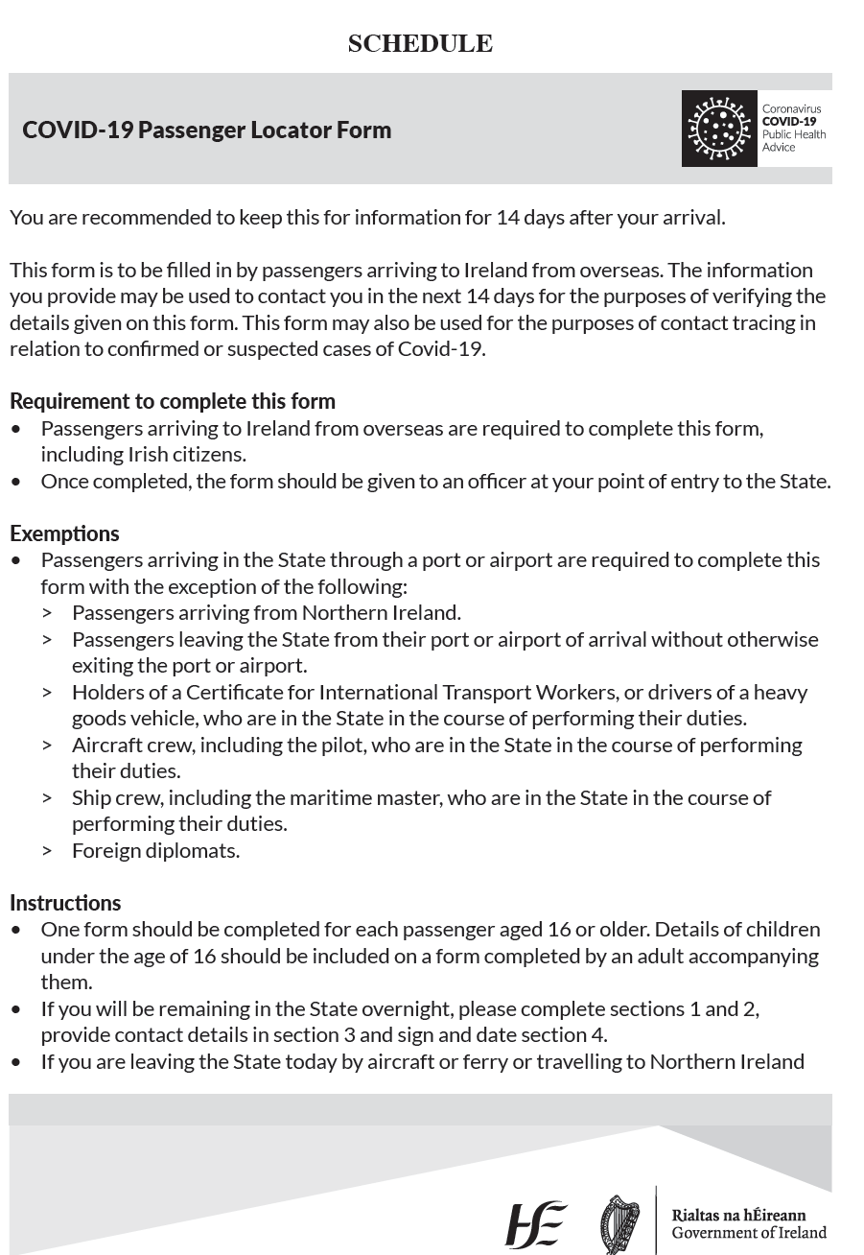

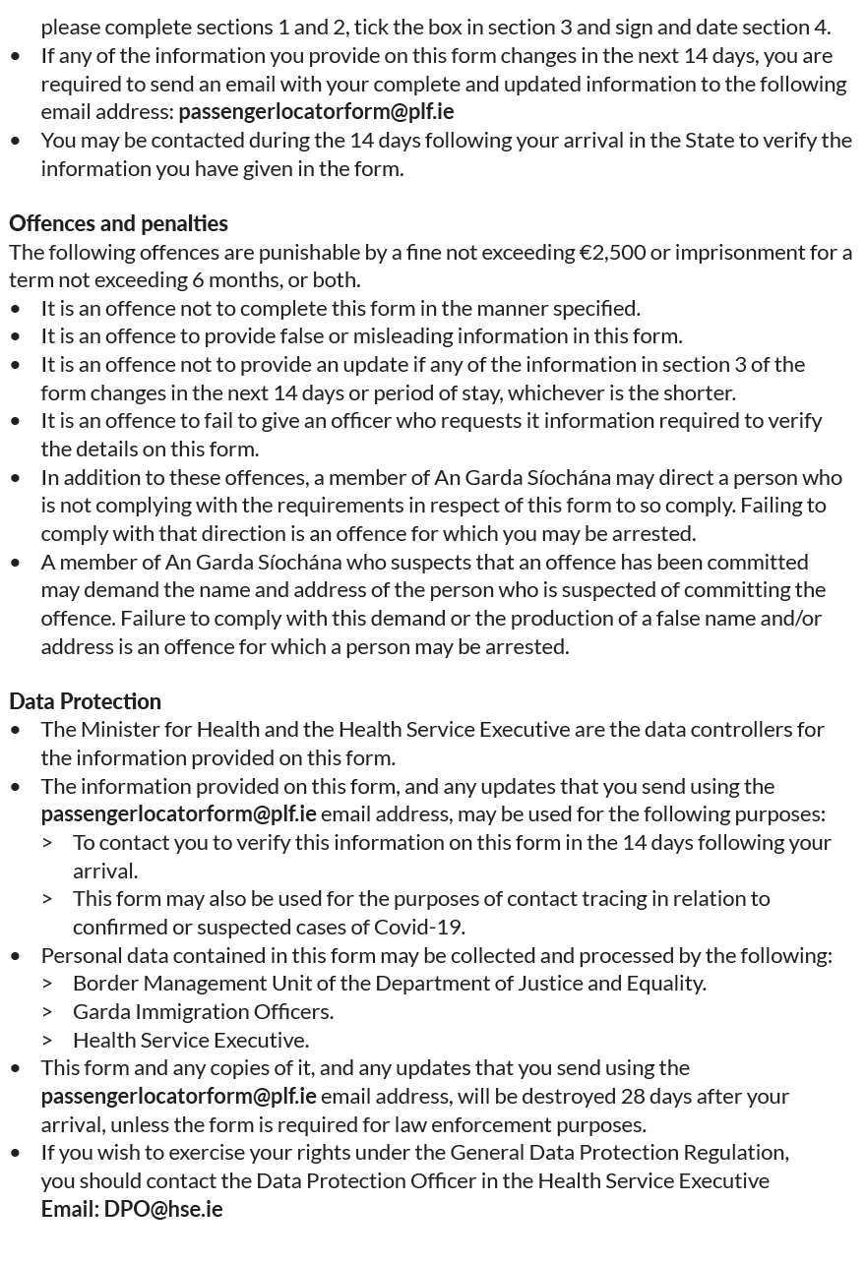
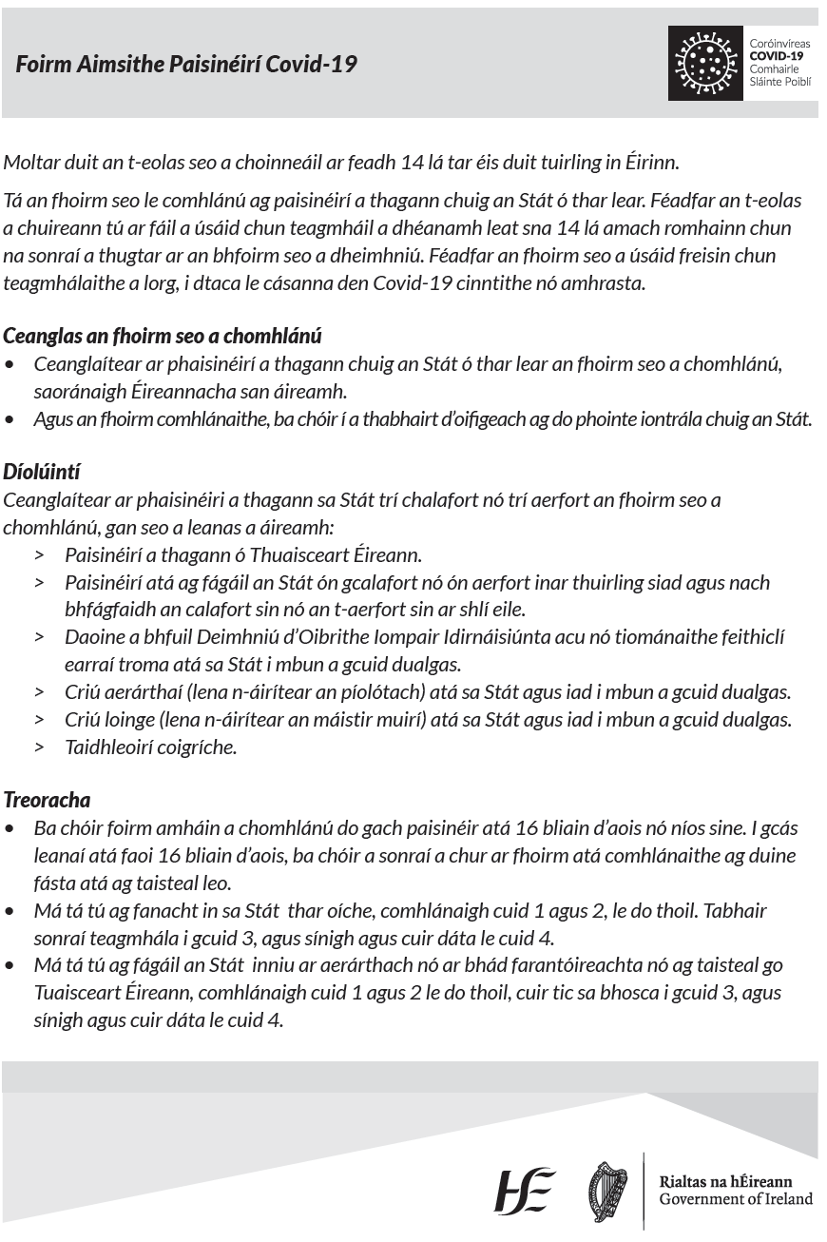
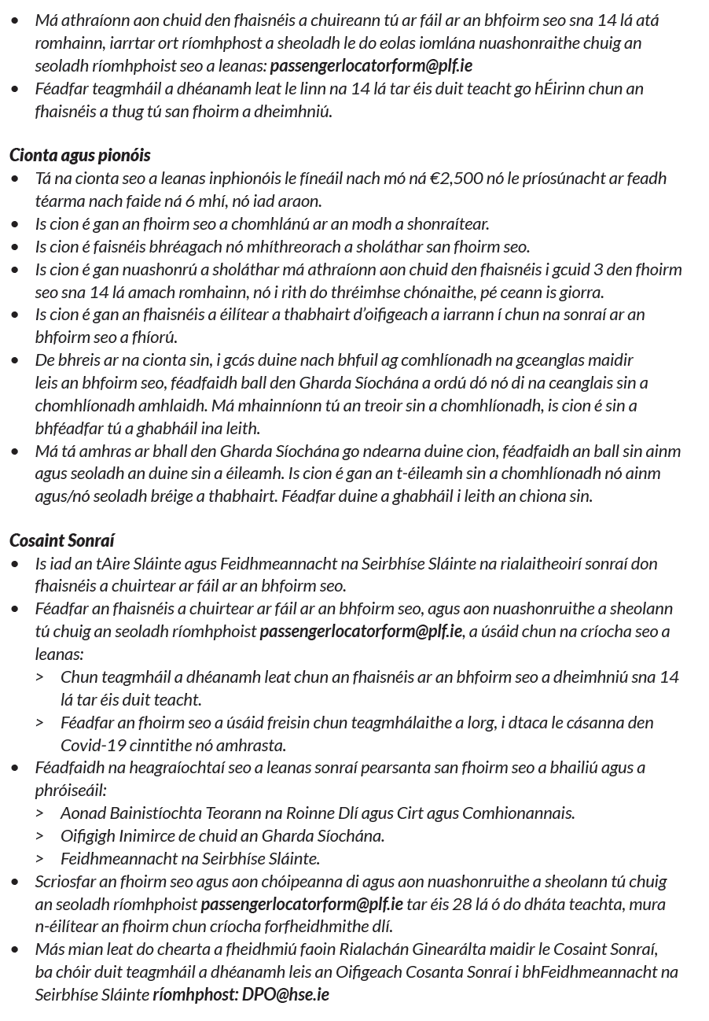
12 [181]
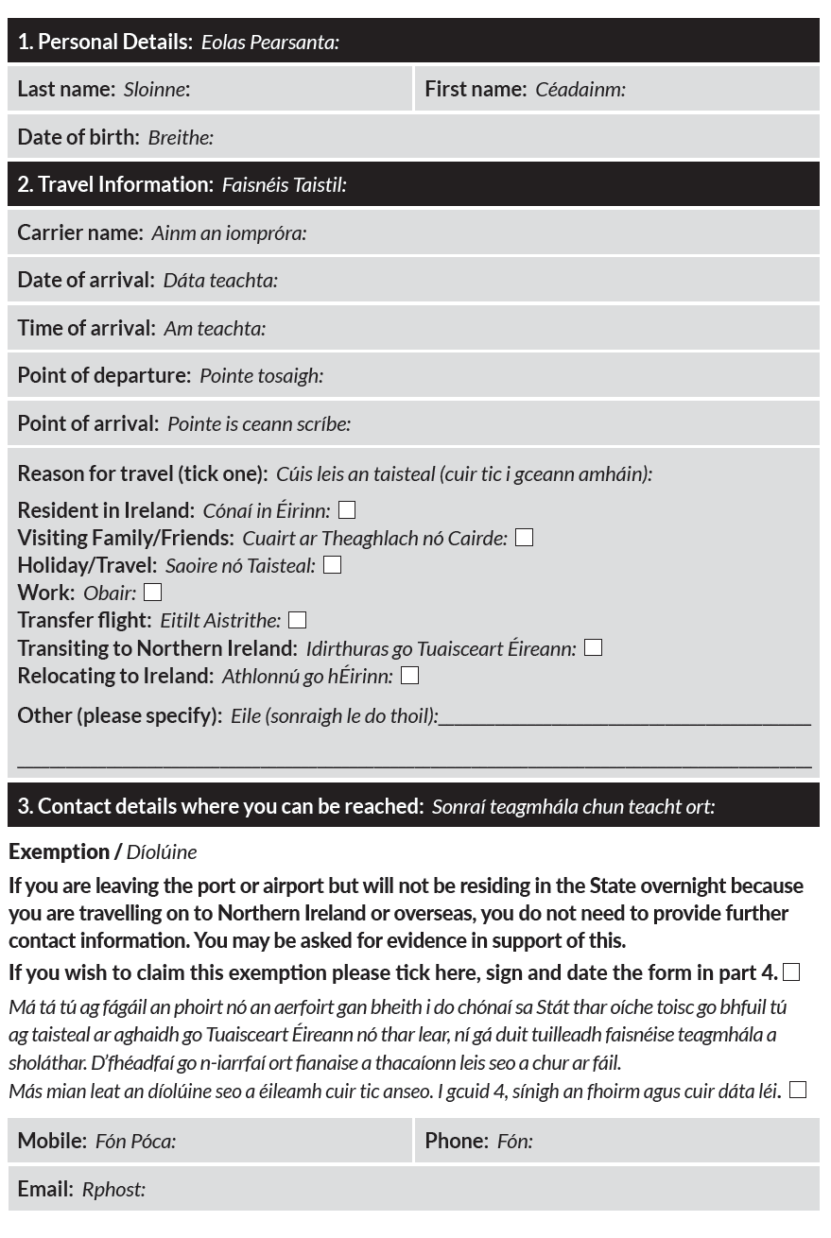
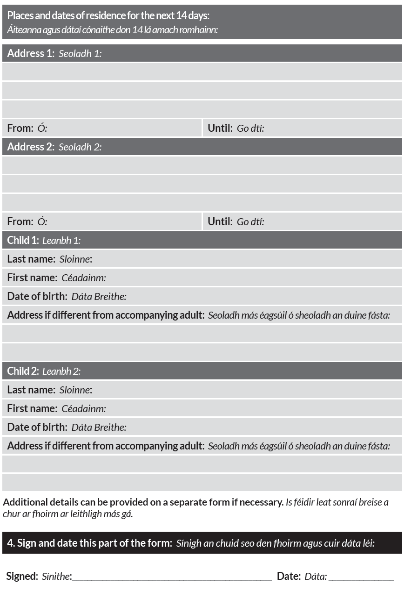
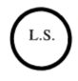
GIVEN under my Official Seal, 24 May, 2020.
SIMON HARRIS, Minister for Health.
EXPLANATORY NOTE
(This note is not part of the Instrument and does not purport to be a legal interpretation.)
These Regulations, made under section 31A of the Health Act 1947 (inserted by section 10 of the Health (Preservation and Protection and other Emergency Measures in the Public Interest) Act 2020), provide for the imposition of a requirement that international passengers (including Irish citizens) arriving in the State at a port or airport from a place outside the State complete a COVID- 19 Passenger Locator Form for the purposes of recording and verifying information regarding their contact details and place of residence for a period of up to 14 days following arrival.

Table of Regulations amending the Temporary Requirements (COVID-19 Passenger Locator Form) Regulations
Title | Date made | Iris Oifigiúil
S.I. No. 217/2020 – Health Act 1947 (Section 31A – Temporary Requirements) (Covid-19 Passenger Locator Form) (Amendment) Regulations 2020 | 17/06/2020 | 19/06/2020
S.I. No. 243/2020 – Health Act 1947 (Section 31A – Temporary Requirements) (Covid-19 Passenger Locator Form) (Amendment) (No. 2) Regulations 2020 | 8/07/2020 | 10/07/2020
S.I. No. 251/2020 – Health Act 1947 (Section 31A – Temporary Requirements) (COVID-19 Passenger Locator Form) (Amendment) (No. 3) Regulations 2020. | 17/07/2020 | 21/07/2020

S.I. No. 244/2020 - Health Act 1947 (Section 31A -Temporary Restrictions) (Covid-19) (Face Coverings on Public Transport) Regulations 2020
Notice of the making of this Statutory Instrument was published in “Iris Oifigiúil” of 14th July, 2020.
I, STEPHEN DONNELLY, Minister for Health, in exercise of the powers conferred on me by sections 5 and 31A (inserted by section 10 of the Health (Preservation and Protection and other Emergency Measures in the Public Interest) Act 2020 (No. 1 of 2020)) of the Health Act 1947 (No. 28 of 1947) and -
(a) having regard to the immediate, exceptional and manifest risk posed to human life and public health by the spread of Covid-19 and to the matters specified in subsection (2) of section 31A, and
(b) having consulted with the Minister for Transport, Tourism and Sport and the Minister for Justice and Equality,
hereby make the following regulations:
Citation and commencement
1. (1) These Regulations may be cited as the Health Act 1947 (Section 31A – Temporary Restrictions) (Covid-19) (Face Coverings on Public Transport) Regulations 2020.
(2) These Regulations shall come into operation on the 13th day of July 2020.
Operation of Regulations
2. These Regulations shall remain in operation until the 5th day of October 2020.
Definitions
3. In these Regulations -
“Act of 2008” means the Dublin Transport Authority Act 2008 (No. 15 of 2008);
“face covering” means a covering of any type which when worn by a person covers the person’s nose and mouth;
“public passenger transport service” has the same meaning it has in the Act of 2008;
“public transport operator” has the same meaning it has in the Act of 2008;
“public transport vehicle” means a vehicle by means of which a public passenger transport service is provided;
“reasonable excuse” shall be construed in accordance with Regulation 6;
“relevant geographical location” means a geographical location to which an affected areas order applies;
“relevant person” has the meaning assigned to it by Regulation 4;
“travel by public transport vehicle” includes boarding a public transport vehicle.
Relevant person
4. The following persons (each of whom, in these Regulations, is referred to as a “relevant person”) are specified as relevant persons for the purposes of these Regulations:
(a) any officer, employee or agent of a public transport operator who is –
(i) in, on, or boarding a public transport vehicle owned or operated by that operator, and
(ii) acting in the course of his or her duty as such officer, employee or agent in connection with the provision of a public passenger transport service on behalf of that operator;
(b) any officer, employee or agent of the National Transport Authority who is –
(i) in, on, or boarding a public transport vehicle owned or operated by a public transport operator, and
(ii) acting in the course of his or her duty as such officer, employee or agent of the National Transport Authority.
Requirement to wear face covering when travelling by public transport
5. (1) A person shall not, without reasonable excuse, travel by public transport vehicle within a relevant geographical location without wearing a face covering.
(2) Paragraph (1) shall not apply -
(a) to a person under the age of 13 years,
(b) to a person driving a public transport vehicle from a compartment in which he or she is the sole occupant,
(c) where there is a screen in a public transport vehicle which separates the driver of the vehicle from persons boarding or alighting from the vehicle, to a person driving the vehicle from behind that screen,
(d) where there is not a screen in a public transport vehicle which separates the driver of the vehicle from persons boarding or alighting from the vehicle, to a person driving the vehicle during the periods when no person is boarding or alighting from the vehicle,
(e) to a member of the Garda Síochána in the course of performing his or her duties.
Reasonable excuse
6. Without prejudice to the generality of what constitutes reasonable excuse for the purposes of Regulation 5(1), a person has reasonable excuse if -
(a) the person cannot put on, wear or remove a face covering -
(i) because of any physical or mental illness, impairment, or disability, or
(ii) without severe distress,
(b) the person needs to communicate with a person who has difficulties communicating (in relation to speech, language or otherwise),
(c) the person removes the face covering to provide emergency assistance or to provide care or assistance to a vulnerable person,
(d) the person removes the face covering to avoid harm or injury, or the risk of harm or injury,
(e) the person removes the face covering in order to, and only for the time required to, take medication.
Powers of relevant person
7. (1) Where a relevant person reasonably believes that a person travelling by public transport vehicle (in this Regulation referred to as a “passenger”) is not wearing a face covering in accordance with Regulation 5, he or she may do any of the following:
(a) request the passenger to wear a face covering;
(b) refuse the passenger entry to a public transport vehicle;
(c) request the passenger to alight from a public transport vehicle.
(2) Before exercising a power under paragraph (1) in respect of a passenger, a relevant person shall give the passenger an opportunity to provide reasonable excuse and may request the passenger to provide such information as the relevant person considers necessary to determine whether or not the passenger has reasonable excuse.
(3) Notwithstanding paragraph (2), the onus shall be on a passenger to establish, to the satisfaction of the relevant person, that he or she has reasonable excuse.
(4) A passenger shall comply with a request or refusal under paragraph (1).
(5) Paragraph (4) is a penal provision for the purposes of section 31A of the Health Act 1947 (No. 28 of 1947).
GIVEN under the Official Seal of the Minister for Health, 10 July, 2020.
STEPHEN DONNELLY, Minister for Health.
EXPLANATORY NOTE
(This note is not part of the Instrument and does not purport to be a legal interpretation.)
These Regulations provide that members of the public shall not, without reasonable excuse, travel by public transport without wearing a face covering. Public transport under the Regulations encompasses all bus and rail services provided under contract with the National Transport Authority (NTA), LUAS services and commercial bus services licensed by the NTA.
It is an offence not to comply with a request by a relevant person to wear a face covering. It is also an offence not to comply where a relevant person refuses entry to a public transport vehicle or where a relevant person requests a person to alight from a public transport vehicle. Relevant persons under the Regulations are officers, employees or agents of public transport operators or the National Transport Authority.
The Regulations do not apply to children aged under 13 years and do not apply, in certain circumstances, to drivers of public transport vehicles.

Table of Regulations amending the Temporary Restrictions (COVID-19) (Face Coverings on Public Transport) Regulations
Title | Date made | Iris Oifigiúil

