Residency Form for Trinity Joint Honours Students

Pursuant to the following regulations in the Calendar for 2024/2025:

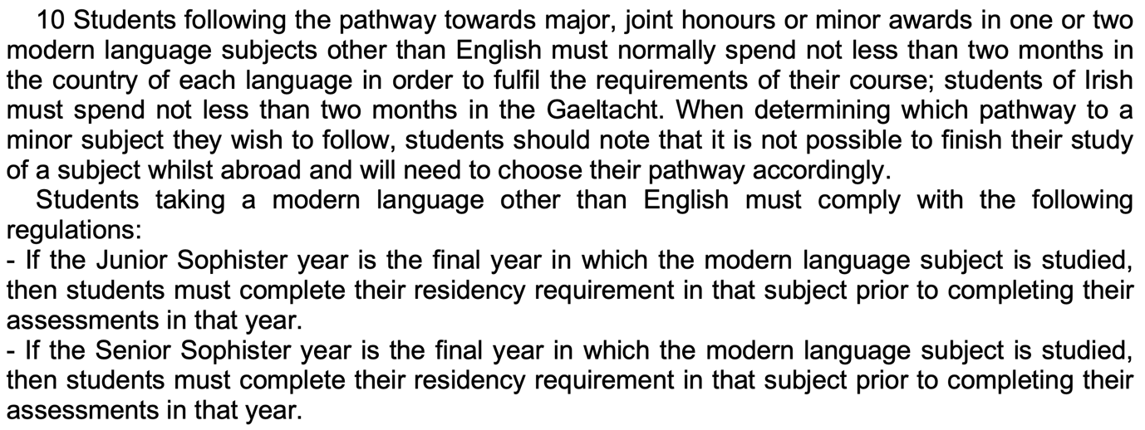
Note – it is not necessary for the time period spent abroad to be one continuous block: multiple stays which add up to cover the minimum are also acceptable.

Please supply the information requested, tick one of the two boxes, and sign and date:

Student name:

Student ID number:

Year of study:

Degree pathway:

□ I confirm in good faith that I have met these requirements, spending the specified period(s) in appropriate countries.

Countries in which the residency requirement was met (list and specify dates for each):

1.
2.
3.

□ I understand that meeting the residency requirement is important for my language learning, and that not meeting it is likely to be detrimental to my academic progress. Notwithstanding this, I state in good faith that circumstances beyond my control made it impossible for me to meet the requirement, and I ask to be exempted from it.

Note – with the approval of the School Undergraduate Committee, in the academic year 2023/24 SS students who tick this box will be granted exemption automatically.

Signature:

Date:

