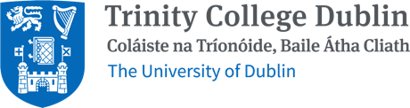
CUSTODIAN BRANDED MERCH BRIEFING FORM

CLIENT NAME
EMAIL ADRESS
CONTACT PHONE NUMBER
DEPARTMENT NAME
PROJECT NAME
PROPOSED BUDGET *If applicable*
DEADLINE

MERCH SPEC
QUANTITY
DO YOU WANT A SUSTAINABLE OPTION?
PRODUCT TYPE
i.e hoodie, notebooks, bags, tech etc
DO YOU WANT THIS BRANDED?

*Please include any artwork to be printed for this project when returning this form.
PLEASE PROVIDE AS MUCH DETAIL
AS POSSIBLE FOR DESIRED PRODUCT
(SIZE, COLOURS, MATERIALS, ANY SPECIFIC FEATURES OR REQUIREMENTS)

DO YOU REQUIRE A CALL WITH OUR BRANDED MERCH REP?
PLEASE OUTLINE ANY ADDITONAL INFORMATION (EG KITTING REQUIRED, MULTIPLE DELIVERIES,)
DELIVERY DETAILS

SUBMIT BRIEF
EMAIL YOUR REQUEST TO | ciara.whelan@custodian.ie

ADDITIONAL SERVICES AVAILABLE
DESIGN AND PRINT REQUEST PLEASE EMAIL: | design.request@custodian.ie
STOCK MANAGEMENT & WAREHOUSING REQUEST PLEASE EMAIL: | noel.mcdonagh@custodian.ie

