**Personal Development Plan (PDP) for Doctoral Students**

**Introduction**

Reflecting on your skills is essential for your development, both during your PhD and beyond. This Personal Development Plan template should be used as a supporting document**,** after you have completed a Skills Audit, to enable you to reflect further and give evidence for your skills and attributes. You may be required to complete this PDP as part of a module (such as PMRP or Careers and Employability), or use it independently, for example in preparation for your annual review report or confirmation interview. As such, this PDP should be reviewed at least once per year to track your progress in developing a diverse portfolio of skills.

Prior to completing this PDP, you are encouraged to complete a Skills Audit (the [Careers and Employability Skills Audit Tool or](https://www.tcd.ie/Careers/PhD-Module/car_emp_skills_audit/story_html5.html) [PMRP Skills Audit](https://www.tcd.ie/graduatestudies/assets/doc/pmrp-skills-audit-tool.docx)) to help identify your research and professional goals. While these audits differ slightly in content and style, this PDP will enable you to reflect further on your skills and attributes using the Irish Universities Association skills framework ([IUA Doctoral Skills Statement, Third Edition (2021)](https://www.iua.ie/wp-content/uploads/2021/07/IUA-PhD-Graduate-Skills-Statement-2021-final.pdf)).

*Figure 1: Desired skill sets of doctoral graduates identified by the IUA Doctoral Skills Statement*[1]

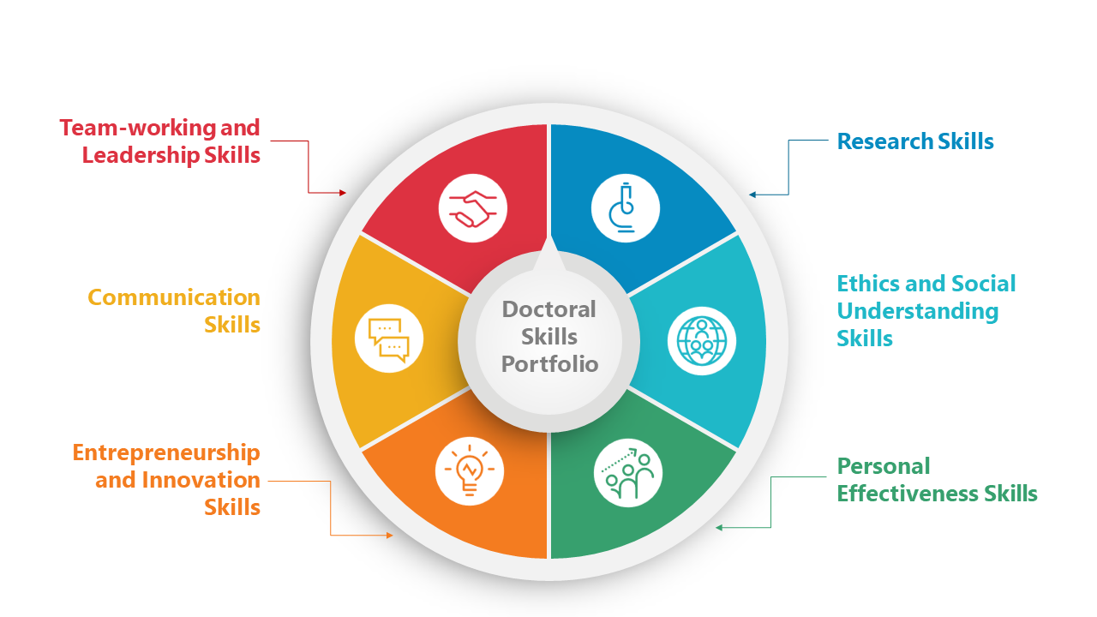

The skills you reflect on will depend on your discipline and the stage you are currently at in your PhD. Choose the skills and attributes that you feel are most relevant to you currently. You may also find that some skills are generic and as such you might need to consider how these are relevant in a broader sense to your specific knowledge and experience. Remember, your skills needs will change as your experience and confidence grows, and they will evolve as you progress through stages of your studies.

A PDP is a snapshot of your skills and attributes at a particular time. While you will be developing skills in each skills area over the course of your doctorate, it is to be expected that certain skills areas need to be prioritised to meet your current or upcoming needs, and/or to align with the content of a particular module. Therefore, don’t worry if you have several skills listed in some areas, and others are not immediately relevant.

Once complete, please reflect on your progress and share with your supervisor(s) for further discussion and engagement prior to the meeting with your Thesis Committee when your personal development plan will be discussed.

**Guidelines**

1. Choose a skills audit to complete.
2. With reference to the *IUA Doctoral Skills Statement, Third Edition (2021)* identify from your skills audit the relevant skills or attributes you want to develop or improve in the following six skills areas:
   1. Research Skills
   2. Personal Effectiveness Skills
   3. Team Working and Leadership Skills
   4. Communication Skills
   5. Ethics and Social Understanding Skills and
   6. Entrepreneurship and Innovation Skills
3. List them in the first column. You can add rows to the table.
4. From the Skills Audit you completed: How did you assess your perceived current ability or confidence in the skill or attribute? Indicate what rating you gave it in the second column.
5. Indicate what positive steps or actions you will take to improve or enhance your skill in that area. What supports will you avail of in College? List them in the third column.
6. Evidence – how will you know if you are making progress on the skill or attribute? Provide points of evidence in the fourth column. Try to be specific.
7. Timeline – indicate when you hope to have achieved the step or action and have attained the measure/evidence in the fifth column.
8. While working on the step or action or on completion of it, reflect on your progress and how you feel about working on this skill or attribute in the final column.
9. To help you get started please see sample PDP in the Appendix.

# Skills Area 1: Research Skills

e.g., data management; research methodologies

|  |  |  |  |  |  |
| --- | --- | --- | --- | --- | --- |
| Skill needed – what specific skill do I want to develop/improve? | Rating (1-5) 1=low, 5=high | What positive steps or actions will I take to improve or enhance my skill? | Evidence – how will I know if I am making progress on this skill? | Timeline – when do I want to have achieved each step or action? | How do I feel about my progress on this skill? |
|  |  |  |  |  |  |
|  |  |  |  |  |  |
|  |  |  |  |  |  |

* *Add rows if needed*

# Skills Area 2: Personal Effectiveness Skills

e.g., critical thinking, self-management

|  |  |  |  |  |  |
| --- | --- | --- | --- | --- | --- |
| Skill needed – what specific skill do I want to develop/improve? | Rating  (1-5)  1=low, 5=high | What positive steps or actions will I take to improve or enhance my skill? | Evidence – how will I know if I am making progress on this skill? | Timeline – when do I want to have achieved each step or action? | How do I feel about my progress on this skill? |
|  |  |  |  |  |  |
|  |  |  |  |  |  |
|  |  |  |  |  |  |

* *Add rows if needed*

# Skills Area 3: Team Working and Leadership Skills

e.g., develop effective relationships, motivate others

|  |  |  |  |  |  |
| --- | --- | --- | --- | --- | --- |
| Skill needed – what specific skill do I want to develop/improve? | Rating  (1-5)  1=low, 5=high | What positive steps or actions will I take to improve or enhance my skill? | Evidence – how will I know if I am making progress on this skill? | Timeline – when do I want to have achieved each step or action? | How do I feel about my progress on this skill? |
|  |  |  |  |  |  |
|  |  |  |  |  |  |
|  |  |  |  |  |  |

* *Add rows if needed*

# Skills Area 4: Communication Skills

e.g., writing and publishing skills

|  |  |  |  |  |  |
| --- | --- | --- | --- | --- | --- |
| Skill needed – what specific skill do I want to develop/improve? | Rating (1-5)  1=low, 5=high | What positive steps or actions will I take to improve or enhance my skill? | Evidence – how will I know if I am making progress on this skill? | Timeline – when do I want to have achieved each step or action? | How do I feel about my progress on this skill? |
|  |  |  |  |  |  |
|  |  |  |  |  |  |
|  |  |  |  |  |  |

* *Add rows if needed*

# Skills Area 5: Ethics and Social Understanding Skills

e.g., apply principles of ethical conduct in research; demonstrate awareness of equality and diversity issues

|  |  |  |  |  |  |
| --- | --- | --- | --- | --- | --- |
| Skill needed – what specific skill do I want to develop/improve? | Rating  (1-5)  1=low, 5=high | What positive steps or actions will I take to improve or enhance my skill? | Evidence – how will I know if I am making progress on this skill? | Timeline – when do I want to have achieved each step or action? | How do I feel about my progress on this skill? |
|  |  |  |  |  |  |
|  |  |  |  |  |  |
|  |  |  |  |  |  |

* *Add rows if needed*

# Skills Area 6: Entrepreneurship and Innovation Skills

e.g., demonstrate innovation and creativity in research, contribute to knowledge exchange

|  |  |  |  |  |  |
| --- | --- | --- | --- | --- | --- |
| Skill needed – what specific skill do I want to develop/improve? | Rating  (1-5)  1=low, 5=high | What positive steps or actions will I take to improve or enhance my skill? | Evidence – how will I know if I am making progress on this skill? | Timeline – when do I want to have achieved each step or action? | How do I feel about my progress on this skill? |
|  |  |  |  |  |  |
|  |  |  |  |  |  |
|  |  |  |  |  |  |

* *Add rows if needed*

**Appendix – Sample PDP**

# Skills Area 1: Research Skills

e.g., data management; research methodologies

|  |  |  |  |  |  |
| --- | --- | --- | --- | --- | --- |
| Skill needed – what specific skill do I want to develop/improve? | Rating (1-5)  1=low, 5=high | What positive steps or actions will I take to improve or enhance my skill? | Evidence – how will I know if I am making progress on this skill? | Timeline – when do I want to have achieved each step or action? | How do I feel about my progress on this skill? |
| Acquire in-depth knowledge of intellectual developments in my field | 3 | Build a reference database with notes. Attend Endnote training and meet subject librarian. | Reference database created and held meeting with subject librarian.  All notes on readings now held on one system. | July 2024  August 2024 |  |
|  |  | Contribute to School/Department knowledge exchange events. | Have made contribution to at least one exchange which was received well. | July 2024 | It is going well. I am nervous about giving presentations but enjoy explaining my research. |

# Skills Area 2: Personal Effectiveness Skills

e.g., critical thinking, self-management

|  |  |  |  |  |  |
| --- | --- | --- | --- | --- | --- |
| Skill needed – what specific skill do I want to develop/improve? | Rating (1-5)  1=low, 5=high | What positive steps or actions will I take to improve or enhance my skill? | Evidence – how will I know if I am making progress on this skill? | Timeline – when do I want to have achieved each step or action? | How do I feel about my progress on this skill? |
| Work-life balance | 2 | Take PMRP module and attend relevant sessions.  Meet/facetime a friend for coffee weekly. | Attended relevant PMRP seminars  Scheduled weekly social time | April 2024  Feb-June 2024 | Struggling to do this weekly. |

# Skills Area 6: Entrepreneurship and Innovation Skills

e.g., demonstrate innovation and creativity in research, contribute to knowledge exchange

|  |  |  |  |  |  |
| --- | --- | --- | --- | --- | --- |
| Skill needed – what specific skill do I want to develop/improve? | Rating (1-5)  1=low, 5=high | What positive steps or actions will I take to improve or enhance my skill? | Evidence – how will I know if I am making progress on this skill? | Timeline – when do I want to have achieved each step or action? | How do I feel about my progress on this skill? |
| I take a creative, imaginative and inquiring approach to research | 4 | Identify new research trends and apply to my research | Attended relevant Departmental seminars  Attended a conference | Feb - April 2024  July 2024 | Feel inspired but need to discuss with my supervisor how to apply the learnings to my research |

1. Adapted from the IUA Doctoral Skills Statement, Third Edition (2021), Irish Universities Association, https://www.iua.ie/wp-content/uploads/2021/07/IUA-PhD-Graduate-Skills-Statement-2021-final.pdf