

Fieldwork Risk Assessment

Large Groups (Fieldcourses)

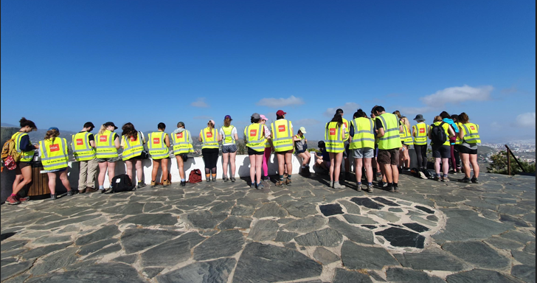

School of Natural Sciences

Trinity College Dublin

https://naturalscience.tcd.ie/

# Fieldwork Risk Assessment for Large Groups

**Data Security Statement**

The personal data collected on risk assessment forms are being requested by The School of Natural Sciences, Trinity College Dublin (TCD) for the purpose of establishing contact details for the researcher and identifying a contactable person in the event of an emergency when the researcher is working in laboratories or away from the TCD campus. These data may be accessed by the Head of Discipline, Project Supervisor, Discipline Safety Officer, Chief Technical Officer or Discipline Technical Officer for contacting the student or researcher or to contact the emergency contact person in the event of an emergency. Your data will only be used for these purposes and will not be released to other parties without your permission, except as permitted by law. You have the right to access your own personal data which you supply here and the right to rectify those data. When submitted, this document will be stored securely on OneDrive at TCD. Your data will be retained until the laboratory work or fieldwork is complete. The information provided will be securely disposed of when the related period of work has been completed.

Please get permission from your contact person for the use of their name and phone number.

**Please read the guidance notes fully before completing all sections of this form.**

**Section A. Personnel and course description.**

1. **Field course module co-ordinator**: Enter name.

1. **Module code and brief description of course and field area**: Enter text here.
2. **Group size (number of students, number of staff):** Enter value, students

Enter value, staff

**Details of Environment(s)**

*Include terrain, rural, urban, cultural differences, language etc.*

|  |
| --- |
|  |

**Section B. Itinerary**

Start Date: Click or tap to enter a date. Return Date: Click or tap to enter a date.

Destination (country / county) Click or tap here to enter text.

|  |  |  |
| --- | --- | --- |
| **Date** | **Location(s) include GPS where possible** | **Activities** |
|  |  |  |
|  |  |  |
|  |  |  |
|  |  |  |
|  |  |  |

Has this information been communicated to the students and staff already as it may influence their Health Declaration Y/N

**Travel Plan and Accommodation**

*Provide an outline of the travel plans for getting to and from the field area and for travel within the field area. Ensure driving times are not excessive and that sufficient drivers and breaks are included in the plan.*

|  |
| --- |
|  |

1. **Persons and contacts**

**Who Will Be At Risk?**

**Students:**

|  |  |  |  |  |
| --- | --- | --- | --- | --- |
| **Name** | **Student Number** | **Health Declaration Completed Y/N** | **Contact and insurance information Y/N**  (can be confirmed closer to leaving date) | **Conduct Form signed**  **Y/N**  (can be confirmed closer to leaving date) |
|  |  |  |  |  |
|  |  |  |  |  |
|  |  |  |  |  |
|  |  |  |  |  |
|  |  |  |  |  |
|  |  |  |  |  |
|  |  |  |  |  |

**Staff**

**Name**(s) and status of staff(s) Academic, Professional, Research Assistant, Other

Name: Staff member’s name.

Choose a position.

Email address: Enter email address.

Phone: Mobile only

Name: Staff member’s name.

Choose a position.

Email address: Enter email address.

Phone: Mobile only

Name: Staff member’s name.

Choose a position.

Email address: Enter email address.

Phone: Mobile only

Name: Staff member’s name.

Choose a position.

Email address: Enter email address.

Phone: Mobile only

Have all staff notified college insurance of their intent to travel Yes/No

**Emergency contacts**

|  |
| --- |
|  |

*How can you best contact the emergency services during the field-course in the event of an accident? e.g. mobile or satellite phones, location of public phones, contact numbers, bus company, local guide etc. Include daily reporting and communication systems e.g. check in times, contact person, procedures to convey change of plan to all etc.*

Has the contact person been advised of reporting system and procedure to follow should reporting system fail. Yes/No

Have you provided the contact person with a copy of this risk assessment? Yes/No

1. **Hazards, Risks and Controls** (add additional rows if required)

Using the accompanying checklist document evaluate and control for all foreseen hazards. Use the risk matrix and aspire to post controls values ≤ 10.

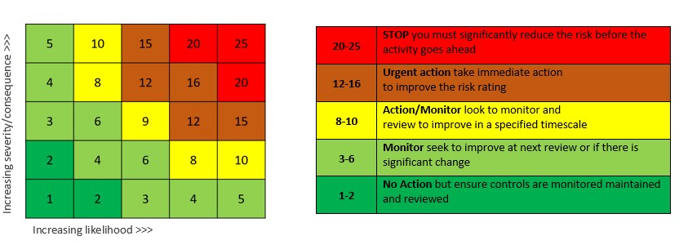Please be as descriptive as possible. Attached additional documentation if you feel it is necessary.

**Geographical, Equipment and Field Location Hazards (add additional rows if required) :** e.g. proximity to water, early/late sampling, mountains

Name/Location: Pre-controls Controls: Post-controls

(GPS co-ordinates) rating: rating:

|  |  |  |  |
| --- | --- | --- | --- |
| Click here to enter hazard. | Choose a value. | List controls. | Choose a value. |
| Click here to enter hazard. | Choose a value. | List controls. | Choose a value. |
| Click here to enter hazard. | Choose a value. | List controls. | Choose a value. |
| Click here to enter hazard. | Choose a value. | List controls. | Choose a value. |
| Click here to enter hazard. | Choose a value. | List controls. | Choose a value. |
| Click here to enter hazard. | Choose a value. | List controls. | Choose a value. |
| Click here to enter hazard. | Choose a value. | List controls. | Choose a value. |
| Click here to enter hazard. | Choose a value. | List controls. | Choose a value. |
| Click here to enter hazard. | Choose a value. | List controls. | Choose a value. |
| Click here to enter hazard. | Choose a value. | List controls. | Choose a value. |

**Chemical Hazards (add additional rows if required)**: e.g. ethanol, hydrogen peroxide, dry ice

|  |  |  |  |  |  |  |  |  |
| --- | --- | --- | --- | --- | --- | --- | --- | --- |
| Name | CAS  No. | OELV | Quantity | Conc. | Labels (Tick all that apply) | Pre-controls  rating | Controls | Post-controls  rating |
| Chemical Name | Enter No. | Exposure Limit Value | In g/Kg or mls/L | Percentage or molarity | |  |  |  |  |  |  |  |  | | --- | --- | --- | --- | --- | --- | --- | --- | |  |  |  |  |  |  |  |  | |  |  |  |  |  |  |  |  | |  |  |  |  | | Choose a value. | List controls. | Choose a value. |
| Chemical Name | Enter No. | Exposure Limit Value | In g/Kg or mls/L | Percentage or molarity | |  |  |  |  |  |  |  |  | | --- | --- | --- | --- | --- | --- | --- | --- | |  |  | ☐ |  | ☐ |  | ☐ |  | | ☐ |  | ☐ |  | ☐ |  | ☐ |  | | ☐ |  |  |  | | Choose a value. | List controls. | Choose a value. |

1. **Additional Information**

Consider inoculations and vias required, regular checks of Department of Foreign Affairs travel site, indemnity forms for work on private land, ethical requirements.

|  |
| --- |
|  |

**Approval**

I confirm that I have read the School of Natural Sciences’ Fieldwork Safety Manual, Risk Assessment Guidance Notes and Checklists before carrying out this risk assessment and that the information provided conforms to the guidelines detailed in these documents.

*Print your name, sign, and date. Electronic signatures* are acceptable.*

Send to [NatSchHandS@tcd.ie](mailto:NatSchHandS@tcd.ie) for further examination. Overseas field course risk assessments will be forwarding to college insurance and Safety Office.

**Name** **Sign\*** **Date** Click or tap to enter a date.

**__________________________ _______________________________**

**Approved By** (SO, HoS)** **Name Sign Date**Click or tap to enter a date.

**______________________ _____________________________ __________________________**

**Approved By** (SO, HoS)** **Name Sign Date**Click or tap to enter a date.

**______________________ _____________________________ __________________________**

*\*An electronic signature is required. Do not type your name in this box or apply handwriting font. In accordance with Regulation (EU) No 910/2014) and Section 22 of the Electronic Commerce Act 2000 an electronic signature must meet the following requirements (a) it is uniquely linked to the signatory; (b) it is capable of identifying the signatory; (c) it is created using means that are under the signatory’s sole control; and (d) it is linked to other electronic data in such a way that any alteration to the said data can be detected.*

\*\**All field courses taking place in Ireland must be signed by a Safety Officer. Courses taking place outside Ireland will require a further signature from Head of School before going to Insurance and College Safety*