Supporting Students with Asperger’s

Syndrome and other Autistic Spectrum

Conditions in the 4th Level College Environment
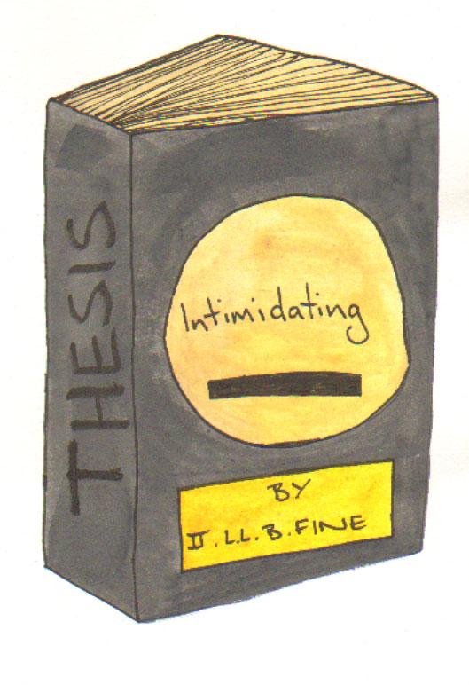
Written by Dr. Zehanne Kenny (deceased) and updated by Declan Treanor (2015)

Contents

Introduction 3
A. Post graduate Studies – some issues to consider Asperger’s Syndrome 4
B. Supervision 5
C. Supervisors 6
D. The Viva 7
E. Things Post grads might expect to do 8
F. Structuring your time 12
G. Beyond The Viva – advice for those working with 4th level students 14
H. Further reading 16

Introduction
Students with Autistic Spectrum Disorders such as Asperger’s Syndrome (AS) are now being increasingly represented at fourth level, placing them in situations which may cause significant problems. This document should be read in conjunction with the ‘Supports available for students with Asperger’s Syndrome and other Autistic Spectrum Conditions in the 3rd Level College Environment’ which can be found on the TCD web at: http://www.tcd.ie/disability/services/AS-Support/index.php as some of the issues at undergraduate level will be relevant to those studying at graduate or 4th level. This guide focuses on identifying and, hopefully, solving some of the most pressing ones, and is addressed to anyone considering post-graduate or even post-doctoral study. It begins by broadly considering the ‘plus’ and ‘minus’ aspects of fourth level education, then goes on to look at supervision issues, issues regarding the expectations which most colleges have their research students, the need to be pro-active (often in an ‘outside the box’ way) together with some suggestions for self-structuring time.
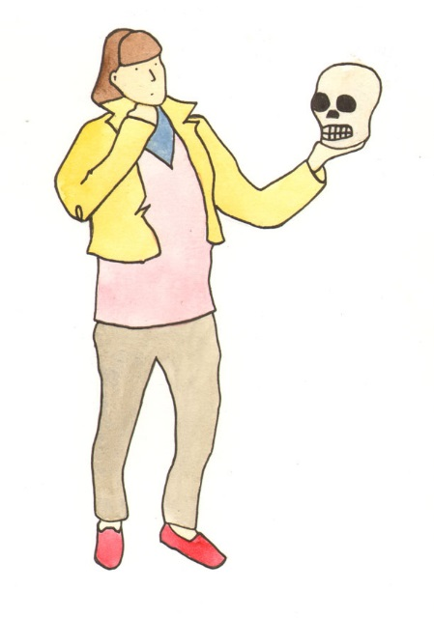

A. Post graduate Studies – some issues to consider Asperger’s Syndrome
Basically you have to decide whether the ‘plus’ factors outweigh the ‘minus’ ones in your particular case.
- The ‘plus’ factors: Postgraduate study, and hopefully, a career in Academia will allow you to indulge your passion for a chosen subject while at the same time adding to the universal body of knowledge in your field, it will put you on the track for a fulfilling and financially viable lifestyle…but
- The ‘minus’ factors: A postgraduate course of study is one where even the fairly loose structure of undergraduate study tends to break down.
The second major problem area will be the transition from post-grad to employed grad – a problem faced by everyone but which may cause you far more trauma.
Before discussing life beyond your qualification, it might be as well to briefly overview some of the ways in which under and post grad study differs.
Summary
- Plus factors of post-grad study include concentration on a chosen specialty, and being in a position to do new research in that area
- Minus factors include lack of structure and uncertainty about the future.

B. Supervision
An awful lot depends on your relationship with your supervisor, because he or she will replace all the lectures, tutorials, assorted points of contact which undergrads envoy. This may seem like a daunting prospect, but actually it is a very good introduction to the kind of situation you will encounter if you remain in academia.
A huge proportion of your day will require self-structuring, and you may find this is an even more difficult task than your thesis!
The role of your supervisor needs to be clarified as soon as possible. Both of you must understand and accept the scope and limits of this role. Supervisors – in addition to time spent with and on you, must teach, pursue their own research, supervise other post grads and live a private life. Their main commitment to you is to guide your research and to constructively criticize your output.
The fact that you are on the Autistic Spectrum must be explained before any academic work is produced and submitted for comment.
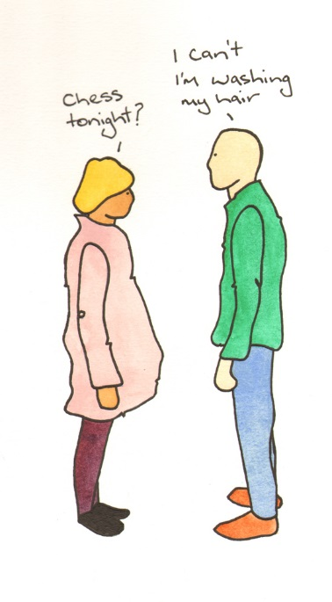
Here are a few suggestions for you to bring to the attention of your supervisor.

C. Supervisors
Remember that a meeting - any meeting, is a potential stressor. Minimise this by switching off all phones and leaving ‘Do Not Disturb’ on the door. If you cannot come to the meeting give as much notice as possible and sincerely apologise - anyone with A.S. will be very upset.
Feedback is vital - not only for academic work but for any interaction with the student. If the student requests a meeting be cancelled or rescheduled, or otherwise alters something prearranged, give feedback. A simple note saying “It’s OK” will prevent much unnecessary anxiety on the student’s part.
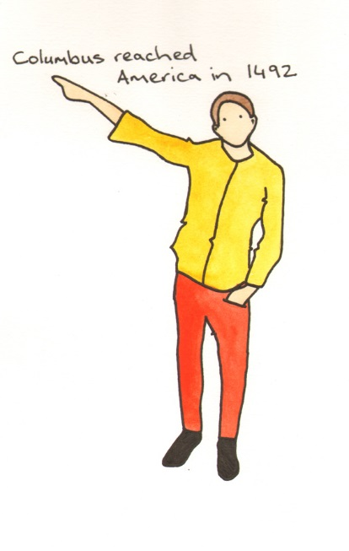Good rules of thumb - treat a student with A.S. as if they are a foreign visitor - be polite and eager to learn about them and their customs. Do not assume they will understand the need for some form of initiatory dialogue. Ask and be prepared to explain your own position.
“I’m fine” coming from a student with A.S. A.S.D is not always the truth. You will need to sympathetically observe in order to ascertain whether they are merely using a strategy of telling you what they think you want to hear - a strategy which may have been useful in past dealings with others, but can be counterproductive in academic situations.
Structure meetings carefully, informing the student beforehand or in the opening few minutes what you wish to discuss. Silences, gaps, searching the room from mislaid material and forgetting to bring along everything required is counterproductive.

D. The Viva
Be careful with attempts to put the student at ease. A few minutes chatting, exchanging pleasantries about the weather can seriously destabilise someone with A.S, most of whom will only chat to established friends, and usually not in a ‘lovely day isn’t it?’ way.
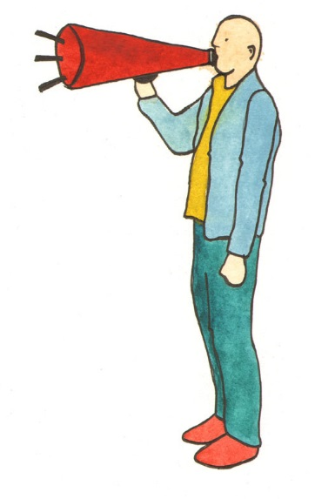Don’t expect or try to maintain eye contact. Rudeness is not involved when someone with A.S looks away or at the floor – it simply represents an alternative style of body language.
As with all meetings - interruptions should be minimised – light levels, noise, people knocking, etc. If possible the room where the viva occurs should be isolated from the main body of the college.
Structure the process and inform the student of exactly how things will go. Communicate this in advance and, once agreed, stick to it! Changes can cause major difficulties. If questions about the student’s future plans are to be included, make sure they have had adequate time to prepare an answer.
Remember - most people with A.S. will treat every question as very important. Be aware of this!

E. Things Post grads might expect to do
In order to demonstrate your commitment to your subject – and the fact that you can work both creatively and industriously at it, post-grads are expected to be pro-active rather than passive students.
Three main areas are:
- Publishing in Journals
- Attending and contributing to conferences
- Teaching
Generally (1) will not be an insurmountable difficulty for students on the autistic spectrum, (2) and (3) however, may well be.
- Publishing in Journals
Your supervisor may help with this – not only by suggesting relevant publications to approach but perhaps by reading and commenting on the paper itself. However –don’t be surprised if they are too busy – having work extend to your thesis commented on and read is a privilege not a right.
- Attending and contributing to conferences
The benefits of this do not need to be spelt out – contacts get made, useful links created, your ideas inspire others/their ideas inspire you – in conversations main points get teased out which, when published, may be left dangling…but to someone on the autistic spectrum the logistics of getting themselves physically to a conference, then finding somewhere to eat and sleep, could be very daunting.
Before committing yourself to attend make sure you have planned adequately for the mundane but crucial aspects of re-locating yourself.
It might well be the case that, having thought long and hard, you decide that going to conferences may be a surmountable stressor. If so, you need to make this clear to your supervisor. You do not want something like this to be perceived as lack of motivation on your part.
- Teaching
Can you teach? Knowing a lot about a subject does not necessarily enable you to teach. As a post-grad you may get the opportunity to take tutorials. These small groups of undergrads will act as a good introduction to the world of teaching – and teaching is an almost inescapable fact of an academic career.
Even if you find a small group manageable, you need to consider whether, in time to come, a larger group which may lack motivation and present disciplinary challenges is equally manageable.
Be Proactive!
Whether or not you can publish / attend conferences / teach, you need to be proactive about your subject. You need to suggest alternative ways of demonstrating commitment and industry. If, for example, you can’t go physically to a conference, then some form of virtual reality attendance may be possible. E-mails, blogs, web-links etc. are increasingly being utilised – embrace the technology and use it to enhance you participation.
But….
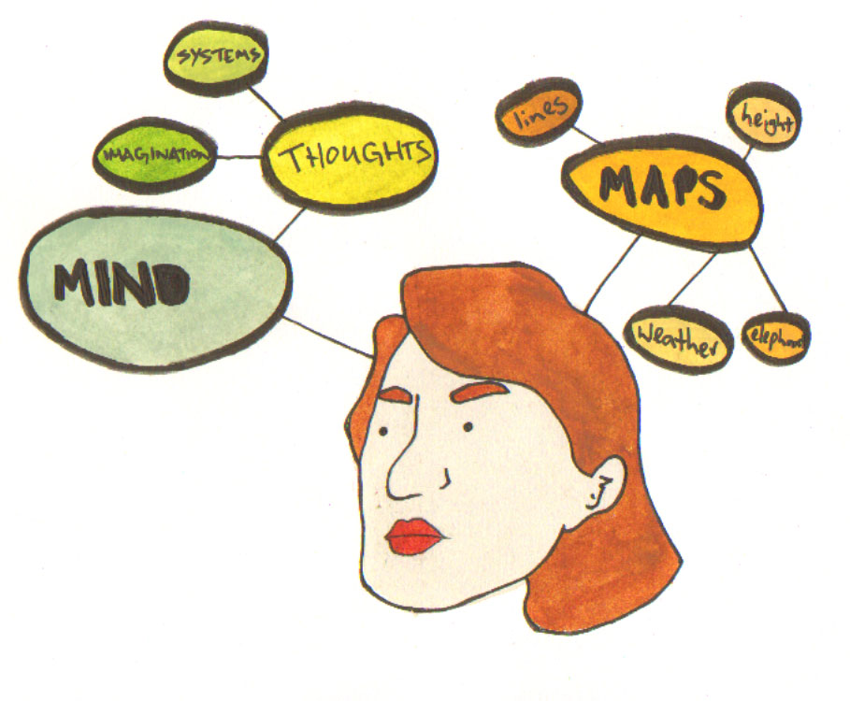Warned!
Good ideas – in any field are like gold ingots. Be wary of giving away pre-publication info from your thesis or articles. You don’t want to see something in a Journal which contains unacknowledged ideas of yours – be careful when talking with apparently friendly, apparently genuinely interested strangers at conferences (in reality or electronically).
Summary
- Post-grads need to pro-actively demonstrate commitment to both their subject and hard work.
- Publishing in Journals is a good way of doing this – but your supervisor may be too busy to be of much help.
- Conference attendance is good – but not if you think it will be too stressful – explore alternatives.
- Make sure you explain why you may not be able to attend – you do not want to be perceived as lazy or unmotivated.
- Be careful of your precious unpublished ideas
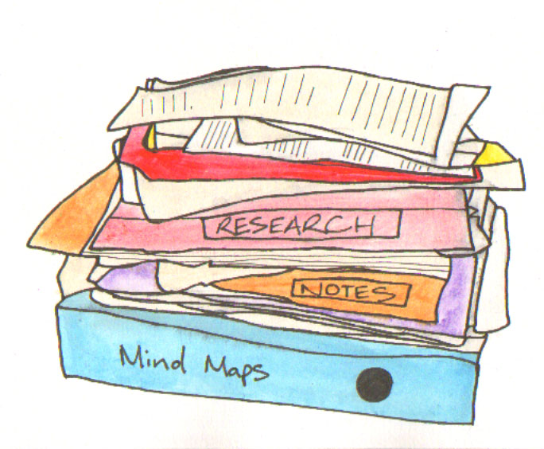

F. Structuring your time
This is a vitally important skill, and, once mastered will be invaluable throughout your academic career.
Instead of the useful lecture / tutorial etc. undergrad, timetable, all you can have are supervisory meetings. These are subject to negotiation, but will generally not occur more than once or twice per month. Your supervisor might even be away for part of the year, and your meetings will be reduced or replaced by E-mail.
It is up to you to make – and stick to – your own personal time table.
A Personal Timetable Approach
This should prioritise study – including preparation of work for your supervisor but should also include time for the necessary cleaning / eating / shopping / etc. things which are very easy to ignore or do badly, haphazardly and inadequately.
Beside study and ‘house-keeping’ the timetable should make provision for exercise – gym or walks or team games if these suit you. Walks are about the best way of getting healthy outdoor exercise while seeing interesting aspects of the natural and the built environment.
Even if you think you know the surroundings fairly well, a good local guidebook, directed at English speaking non-locals, can be a real eye-opener.
There are always places of interest to discover, museums, galleries, stately homes and birth places, besides zoos, parks and nature trails. For example, he most non-descript area of shoreline can come magically alive at low-tide due to seabirds delving (melodiously) for small things in rock pools and buried in sand.
A good idea – for a stimulating day out is to go somewhere which has no connection with your main subject area and interests. Biologists might try a transport museum – chemists and physicists might go to a botanic garden. Inspiration for new projects can often be found where least expected.
For those who may need to face a Viva, the Following List of recommendations should be shown to your supervisor and discussed if necessary. Some simple, even trivial circumstance could seriously affect your performance on the day.
The Future
This is not some mysterious: ‘and they all lived happy ever after’ scenario. The future must be planned for and worked towards in the present. You do not want to spend the final year of your study alternately worrying over ‘what next’ and losing the plot of your research.
As early as possible, start net-working. Careers advisory services should be consulted – even if the best they can say is ‘Finish your Thesis’. They will almost certainly be able to give you some ideas.
Internet net-working is another good idea; see what’s out there and who’s doing what in your field. You might hit a good connection and impress someone with your initiative, even if you have another few years to go before completion.
Your supervisor may be able to arrange post-doctoral research – don’t ignore your own department and risk losing a good opportunity because you’re gazing into websites in other continents.
There may be mundane but useful pieces of work in your own university, such as stacking library books. As well as providing cash, you never know who might be observing and being impressed by your ability to do even a routine job well.
Decide what kinds of things you need in order to have a reasonably fulfilling life. Money – in large amounts and the trappings of affluence may be less important than having access to an academic community and a University Library.
At the same time you need to play up your strengths and avoid getting involved in anything which will cause major stress and highlight your weakness. An academic career will almost always involve teaching – if this definitely doesn’t suit you need to try and find a way around it – and you need to do that as soon as possible.
Having something plausible for the future is a tremendous help, particularly when, for whatever reason, you feel down.

G. Beyond The Viva – advice for those working with 4th level students
What should be a cause for rejoicing could lead to serious problems for the autistic individual (AI), this is largely down to the fact that the qualification is not perceived by them in the same way as it is by the mainstream world.
AIs, however brilliant, often have difficulty structuring their lives. Gaining expertise in one particular field does not necessarily imply a gain in the ability to cope with everyday considerations. We are all familiar with the stereotype of an Einstein-like figure who is unable to function without the structure and support provided by both his college and his wife or housekeeper.
It is therefore vital that a post-viva AI is not left dangling but is given the precise and detailed information which will allow them to progress to the next stage of their career. Failure to do this could result in a confused and unproductive period of unhappiness, or even severe depression. The longer this state continues, the harder it will be to re-establish normal functioning. Comments such as ‘go and celebrate’ or ‘take a well-earned rest’ are pointless and unhelpful, since they are often unrelated to the AI’s expectations of post-doctoral life. For most AIs the process rather than the product of study is the main attraction. A predictable and fulfilling routine, established over a period of time, is the goal. The actual qualification may simply have been sought as a means to continue in much the same mode, possibly for the foreseeable future. Considerations of employment or personal development may not enter into the picture.
It can come as a grotesque shock to find that all the attributes of studenthood, particularly the daily routine and library card are no longer forthcoming, since many AIs will have incorporated these elements as an essential part of their identity.
The transition thus from post-graduate student to post-doctoral researcher, or employee needs to be handled with extreme care.
Key Points
- A mis-match in the way the AI and the rest of the world perceive qualifications can lead to major problems
- Expertise in a chosen field does not necessarily imply ability to cope with structuring future post-doctoral life
- Failure to provide clear and accessible guidelines regarding the next career stage can result in confusion or even depression
- Regarding study – the process rather than its product is often the goal
- The withdrawal of all the attributes of studenthood can severely affect the AI’s self image

H. Further reading
Atwood, T., The Complete Guide to Asperger’s Syndrome, London, Jessica Kingsley 2006
Kenny and Treanor (2008) Supporting Students with Asperger’s Syndrome and other Autistic Spectrum Conditions in the 3rd Level College Environment, Trinity College Dublin
Schopler, E., Mesibov, G.B., Kunce, L.J., Asperger Syndrome or High Functioning Autism?, New York, Plenum Press 1998
Willey, L.M., Pretending to Be Normal, London, Jessica Kingsley 1999
Wing, L., ‘Asperger’s Syndrome: A Critical Account’, Psychological Medicine II, 1981 115-129

Useful Websites
www.aspergersyndrome.org
http://www.tcd.ie/disability/policies/handbooks-downloads.php
Asperger’s Syndrome Supports in Trinity College Dublin
http://www.tcd.ie/disability/services/AS-Support/index.php

